HYBLA
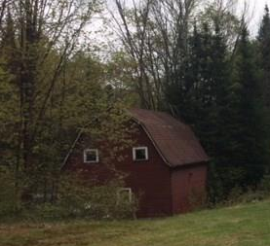
In its heyday, Hybla was a busy hub with a train station and boarding houses, churches a blacksmith and sawmill. While it is still marked with a sign, the three remaining buildings are a store, one home and the old Hybla Gospel Tabernacle which is off to the north side of the ride, in the shrubbery. Located in the Monteagle Hills.

