CAMPBELLFORD
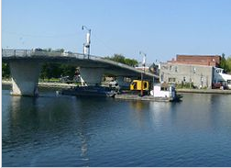
Homesteaders arrived in the Campbellford area in 1834 when the British government deeded 1800 acres to Lieutenant-Colonel Robert Campbell and his brother, Major David Campbell. The Trent River meandered through the brothers’ property (close to the current centre of town). A shallow point, most easily crossed, became known as “Campbell’s Ford”. In 1876, the settlement became the Village of Campbellford. Amalgamating with Hastings & Warkworth in 2001, it is now part of the Municipality of Trent Hills.
Campbellford was home of Charles W Mahoney (Iron Chief Charlie) who started a motorcycle gathering known as Indian Day in 1984. Motorcyclists still gather on the street that runs adjacent to the Trent River, to honour “Indian Charlie Mahoney.”
Empire Cheese & Butter Co-Op
1120 County Rd 8
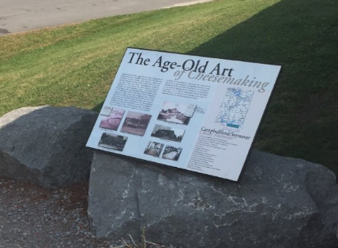
Ranney Gorge Suspension Bridge
At Ferris Provincial Park- 474 County Rd 8
150+ campsites. Great Trails, loop around a forested drumlin.
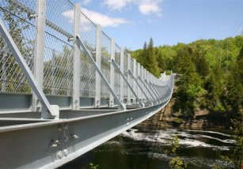
The Ranney Gorge Suspension Bridge is a wonder that you won't want to miss. The beauty of this adventurous journey will change with the seasons. Located right beside locks 11 & 12 at the south end of Campbellford, the Ranney Gorge Suspension Bridge is on the Trans Canada Trail and within easy walking distance from the locks and into downtown Campbellford.
This great, family-oriented, natural adventure hovers 30' above the Ranney Gorge just south of the falls. As you walk across this great expanse your heart pounds as you feel it sway slightly below your feet. Looking down you can see the water rushing by but to the north you see one of nature’s gifts, the Ranney Falls in all its glory. To the south you can see the Trent River and the boats as they enter the locks to come into Campbellford.
When coming to the Suspension bridge you can enter through Ferris Park and all Park fees apply.
http://www.friendsofferris.ca/ranney.html
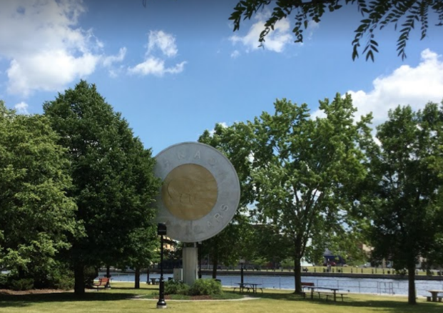
Toonie Monument at Old Mill Park
51 Grand Road
This toonie is 27’ tall and 18’ in diameter. The monument honours Campbellford artist, Brent Townsend, who designed the polar bear that was used on the coin. Townsend is an internationally renowned wildlife artist.
World’s Finest Chocolate
103 Second Street 1-800-461-1957
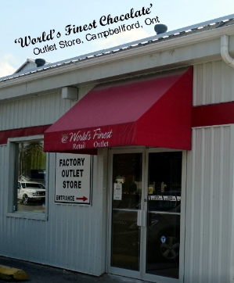
PETHERICKS CORNERS
A hamlet in Campbellford, Ontario.
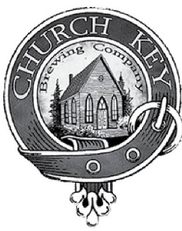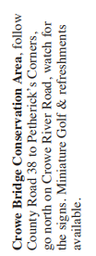
Church-key Brewing
1678 County Rd #38
877-314-2337
Daily 10 a.m. until dusk

In the small hamlet of Pethericks Corners, in Campbellford, this popular craft brewery Brewery occupies a renovated Methodist Church (circa 1878).

