CHEDDAR
A ghost town, west of the village of Cardiff, off Highway 118
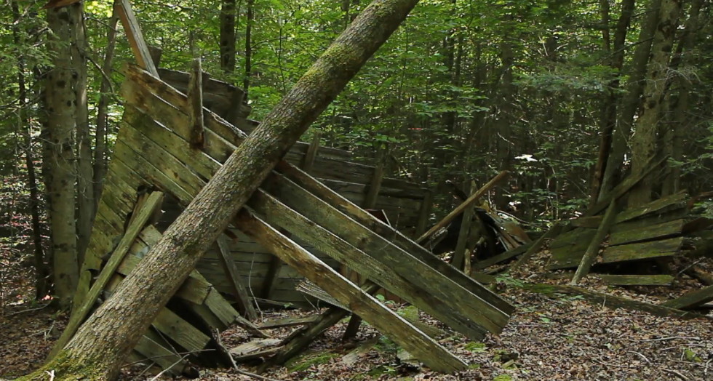
In 1871, this settlement was known as Wood’s Corners on the New Burleigh colonization road. There were 2 general stores, a post office, hotel, blacksmith shop, 2 churches, sawmills and a school. The name was changed to Cheddar in 1890. In 1932, after uranium was discovered in the area, the Cheddar mine opened about a km south of the hamlet. The mine closed around 1942 and in the 50s updated roads were routed around the community. It’s interesting to walk through the area now, to see how the town has been swallowed by the forest.

