VENNACHAR
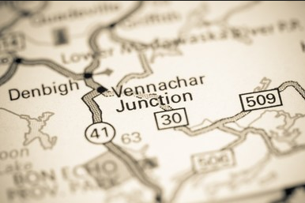
Vennachar was named after a lake in Scotland, where it is said that silver flows. First settled in 1861, by 1865, Charles McKenyon had opened a store and post office.

