CURVE LAKE First Nation Territory
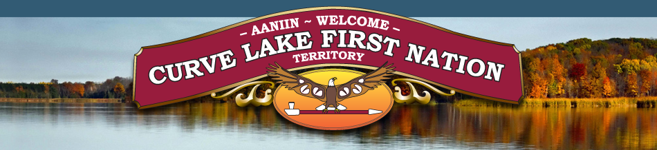
The First Nation territory consists of a mainland peninsula and large island (Fox Island) on Buckhorn and Chemong Lakes. Curve Lake First Nation people are the Mississaugas of the great Anishnaabeg (uhnish-nahbe) nation. The first woman chief in Canada – Elsie Knott (1954); world renowned artisans Norman Knott, Alice Williams and David Johnson and playwright, author and journalist Drew Hayden Taylor have all called Curve Lake home. The Whetung Ojibwa Centre attracts visitors from around the world. All are invited to attend the annual Pow Wow in September.
https://www.curvelakefirstnation.ca/
Whetung Ojibwa Centre
875 Mississauga St
Open daily 9 a.m. to 5 p.m.
info@whetung.com
A spectacular collection of Native crafts, Fine Art, Jewelry, Moccasins, Leather Work, Sculptures and much more more.
