ELDORADO
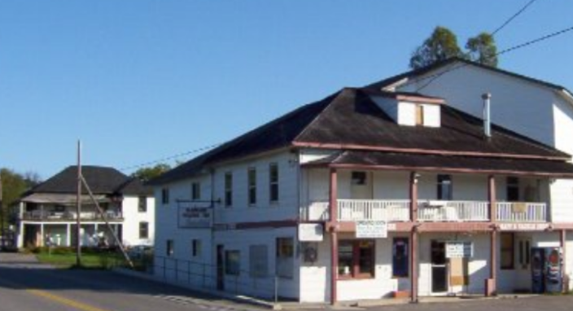
In the mid-1800s, the Irish immigrant farmer John Richardson was weary from trying to farm the outrageously rocky land he’d been struggling to maintain. Legend has it that he hired a young, part-time prospector from the nearby town of Malone (originally known as Powell’s Mills), to explore the property. What they found was copper and over the summer of 1866 rumours circulated about the discovery of gold with nuggets “the size of butternuts”.
The discovery is credited with spurring additional stage lines from Belleville to Madoc, new hotels and a post office as people scrambled to get a piece of the fortune in Eldorado and soon the population grew to near 3,000. It’s been said that 25 mounted police were needed to guard the mining shaft on the Richardson property in 1867. Investors poured money into top-of-the-line machinery, hoping to make billions of dollars.
It turned out that the gold from Richardson Mine was very pure but the deposits were hit and miss. It didn’t take long before the hoopla began quieting down and Richardson and the prospector sold off their rights for about $25,000 combined.
In 1869, with the Richardson Mine closed, Eldorado was still home to a four hotels, a dry goods merchant, a couple of grocery stores, a lawyer and doctor. Records show that the gold mine was operational but by 1871 it only employed 5 or 6 men and the town had dwindled to three stores and a couple of taverns.
By the mid-1880s Eldorado’s population had been reduced to about 75. The party was over and gone were the busy hotels, brothels and taverns. There were three churches and a school just north of the village and a hotel, two general stores and a butcher shop struggled along.
The Town was kept alive during construction of the railroad and in 1883 Eldorado was designated a junction point. Soon the town had its own blacksmith and a wagon maker, a hotel, box factory and shingle mill. Around the turn of the century, a cheese factory and a new store popped up, bolstered by small pockets of people located in nearby Bannockburn, Deloro, Cordova, Marmora & Gold Fleece were other small mines had sprung up.

The Eldorado Experience
Seasonally, you can visit the old Richardson property and take a tour:
Contact: Kim Woodside
5 McCann Crescent, Eldorado, ON K0K 1Y0
(780) 266-7850

