CALABOGIE

Calladh bogaidh: Marshy Bay
By some accounts, this Gaelic phrase is said to be the derivation of the name of what is now Calabogie. Early documents list the place as Calaboga. In those days it referred to the lake and not the town. During the 1840s, at the time of early settlement in what would be Bagot and Blythfield Townships, Springtown was by far the most important community. It was only with the coming of the Kingstown and Pembroke (K & P) railway in the 1870s that the settlement, now known as Calabogie supplanted Springtown in importance….
…. As early as the 1840s, the government was providing assistance to lumber companies by building slides and booms to facilitate log drives on the river. Dams were also constructed at Highland Chute, Mountain Chute, Calabogie and Arnprior to assist operations. It was the damming of the Madawaska around Calabogie that created Calabogie Lake. The lake became a place where logs from the various drives were separated and stored before being floated down to the Ottawa River.
Calabogie Peaks Resort
30 Barrett Chute Rd, Calabogie
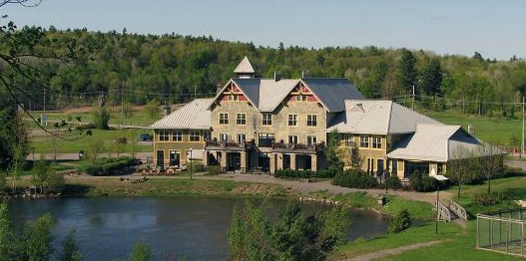
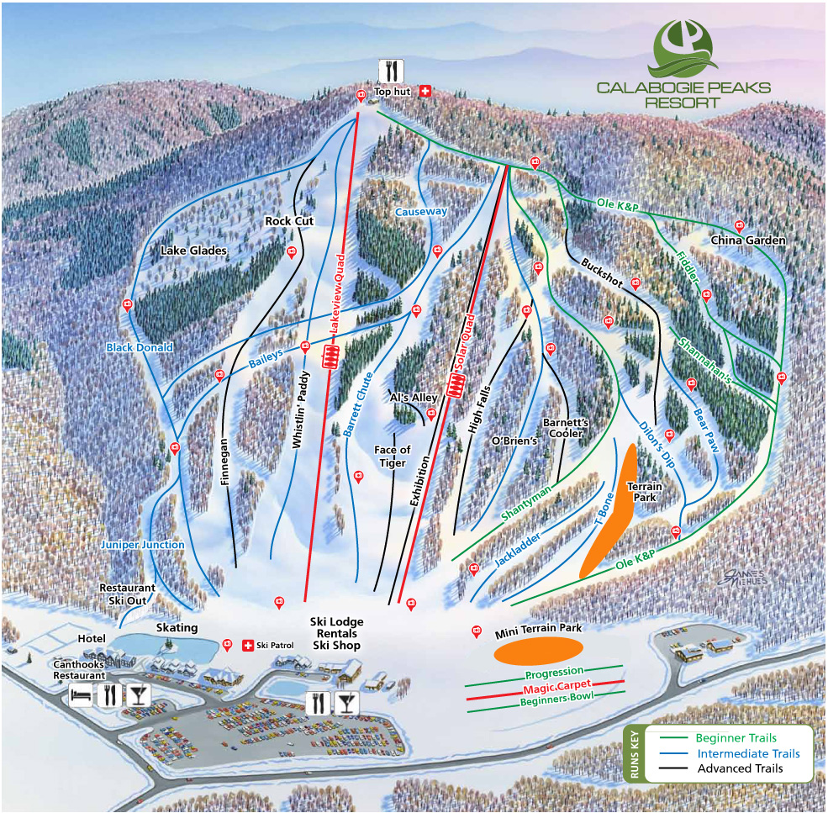

Cross Country Trail
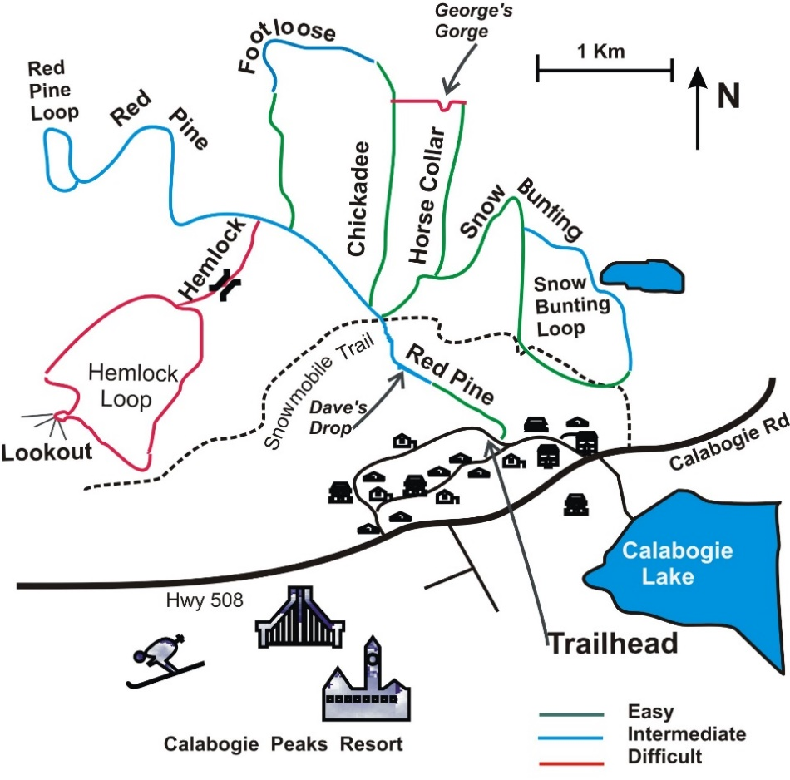

Golf at Ironwoods Golf Course. A 9 hole course, on the shore of Calabogie Lake. (no motorized carts)
For more information on using the beachfront, please call us at 1-800-669-4861 or email us at peaks@calabogie.com
Waterslide
Volleyball Court
Horseshoes
Checker Set
Paddle and enjoy Calabogie Lake from our beachfront (Madawaska River Trail Map)
Bocce Ball
Bonfires
Water equipment rentals & Boat Docking
http://www.calabogie.com/in-the-neighbourhood.html

Skywalk Trail
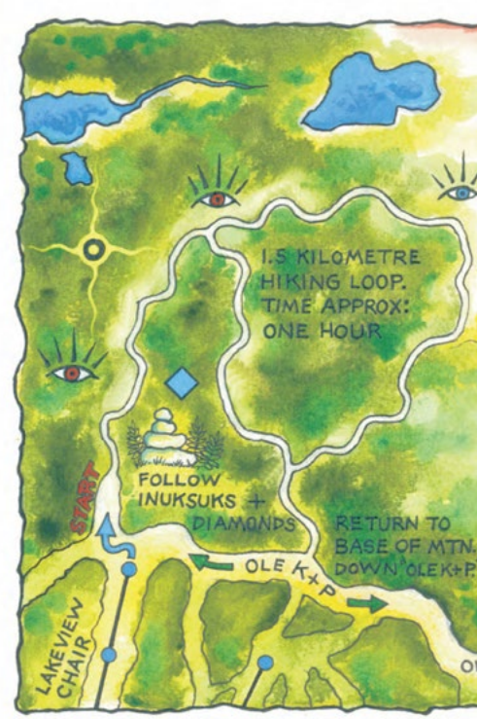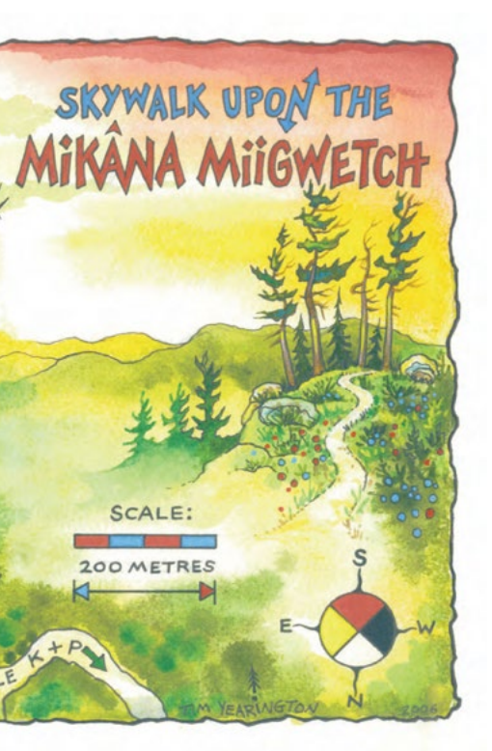
Eagle’s Nest Trail
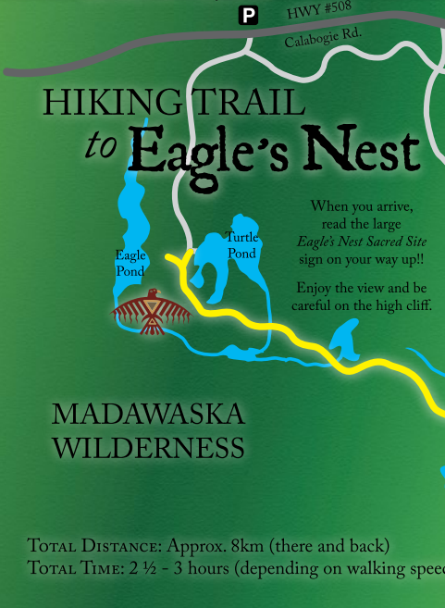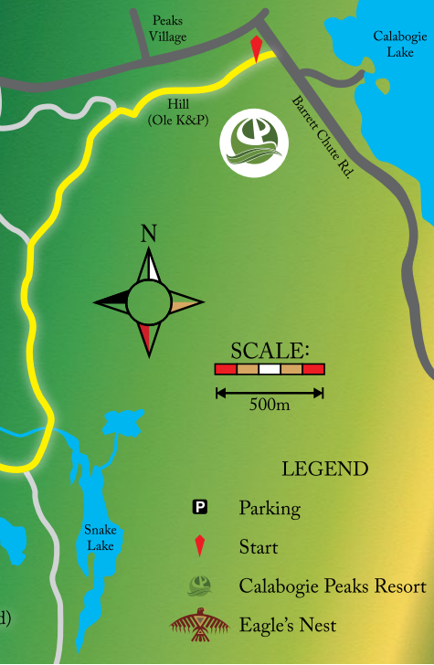

Manitou Hiking & Snowshoeing Trail
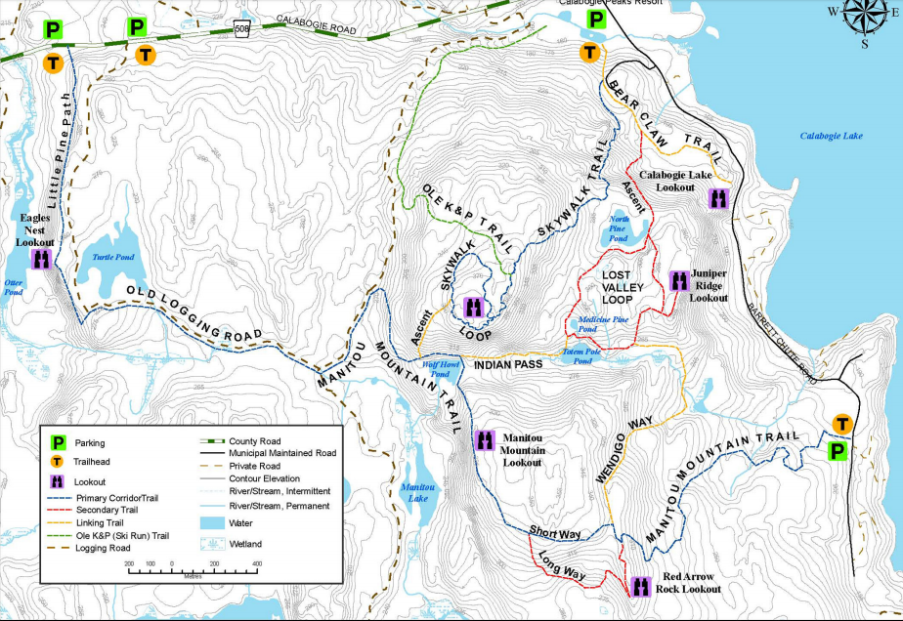

Calabogie Motorsports Park
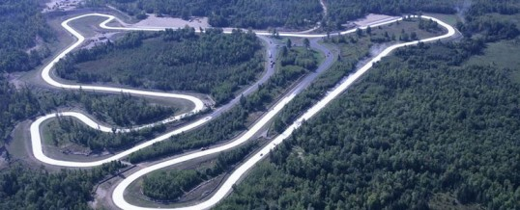
https://www.calabogiemotorsports.com/
Rent a racecar… and other amazing track activities
462 Wilson Farm Road, Calabogie ON info@calabogiemotorsports.com (613)752-1252 or
1-866-669-TRAK
There are lots more things to do in the Calabogie area:

http://www.greatermadawaska.com/municipality/our-community/history/history-calabogie.html

