TRENTON
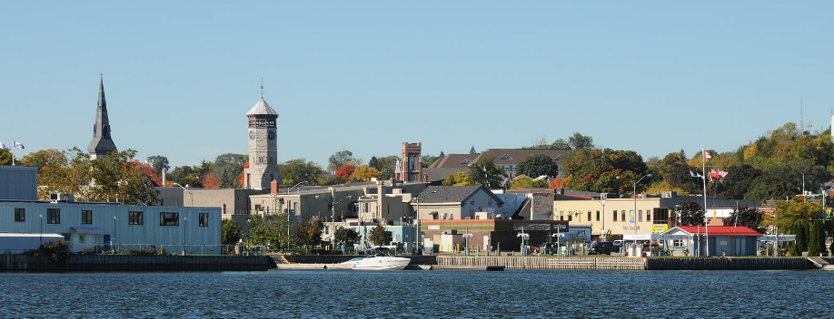

Centennial Park
12 Couch Crescent
613-392-2841

Home to Duncan McDonald Community Arena, amphitheatre, public marina, splash pad, skate park and play equipment. A paved waterfront trail that runs through the park, links with downtown Trenton. There are lots of events held here, throughout the year.

Glen Miller Conservation Area
Hanna Park
At Film Street & Creswell Drive
A 42-acre park with nature trails, tennis courts and play area and off-leash dog park.
qwdogpark@hotmail.com 613-392-6624
https://www.facebook.com/pages/Hanna-Park-Trenton-Ontario/100133753905877
National Air Force Museum of Canada
220 RCAF Rd 613-965-7223
Summer: (May 1 to September 30)
Open Daily 10:00 am to 5:00 pm
Winter: (October 1 to April 30)
Open Wednesday to Sunday 10:00 am to 5:00 pm
Admission $8 for Seniors 65+ and Students 13-17
$10 for Adults 18-64
$5 for Youth 6-12
5 and under free
Families (2 adults, 5 people) $25
Veterans free

Phone: 613-965-RCAF(7223) or 1-866-701-RCAF(7223) for more information.

Fax number: 613-965-7352
http://airforcemuseum.ca/en/
Old Church Theatre
940 Bonisteel Rd Trenton
613-848-1411

This renovated Church (circa 1876) is home of the Roy Bonisteel Studio. Check their website to see what’s playing.

https://oldchurch.ca/

Trent Port Marina
15 Creswell Dr 613-392-2841
At Bayshore Park.
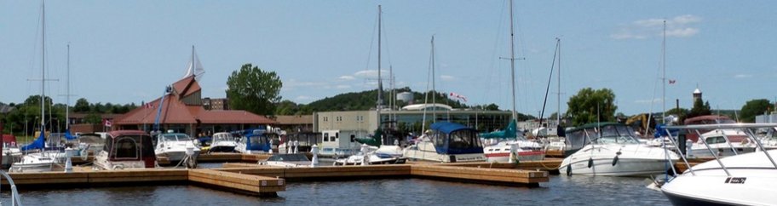

https://www.quintewest.ca/en/marina/Trent-Port-Marina.asp
Trent Port Museum & Heritage Café
55 King Street, Trenton
Operated by the Trent Port Historical Society, this museum is located in the original Town Hall that was constructed in 1861. Open Monday to Friday from 8 a.m. to 3 p.m.
http://www.trentontownhall.ca/
Trenton Clock Tower
Oddly perched at 65 Dundas St W is an old clock tower that was once part of the original town hall.

