HIGHLAND GROVE
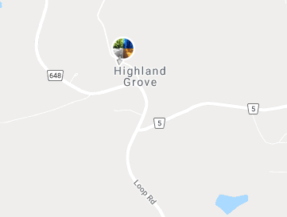
Genealogy Centre
Those interested in genealogy can visit the old Kidd Schoolhouse on Loop Road.
Magnificent Hill
1258 Magnificent Rd, Highland Grove
705-489-9453
https://www.facebook.com/magnificenthill.ca/
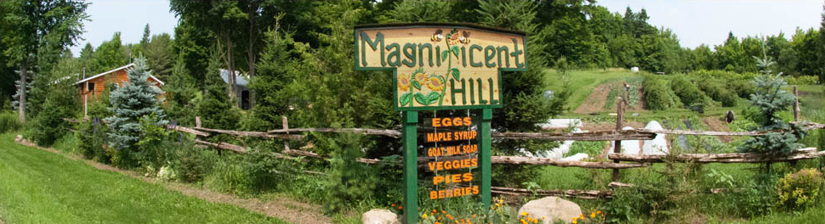
Located 20 minutes south of Algonquin Provincial Park and in the hills of Highland Grove, ON. is a Magnificent Hill. A home and a life-style where we are learning and developing ways to become as self-sufficient and sustainable as possible. We strive to live in harmony with our earth, water and air. We are practicing and developing better ways to grow our food and raise our animals in a chemical free environment. http://www.magnificenthill.ca/
A hilltop organic, homesteading experience near Highland Grove. Many unique opportunities for families or individuals including tours and work-stays. Accommodations are rustic and back to the basics. Bring your own tent or enjoy the comfort of the log dorm with full kitchen. Many building materials have been salvaged from the community instead of ending up in a landfill. The results are unique structures like the privy, shower room, ZenZone and sauna. Moonlit summer evenings on 100 acres, cooking in the outdoor kitchen or pizza from the wood-fired oven. Experiential Learning Programs and Events.

