COMBERMERE
A charming village located along the Madawaska River, Combermere is probably most known as home to the Madonna House. One of the first settlers was John Dennison, who emigrated from England to Montreal in 1825. He took part in the Rebellion of 1837-38, earning himself the title of Captain. From Montreal, he traveled up the Ottawa River, accompanied by his two sons John and Henry. They then ascended the Madawaska River for many miles landing at a spot, which came to be known as Dennison’s Bridge. In 1854, Captain Dennison and his son Henry traveled further to Opeongo Lake and settled there.
Crooked Slide Park
343 Old Barry’s Bay Road
Take a picnic lunch and enjoy the tranquil surroundings. This faithfully restored chute on. Byers Creek is a fine example of chutes used to carry logs over the rocky waters of several Ottawa Valley rivers including the Madawaska, the Bonnechere, and the Ottawa.
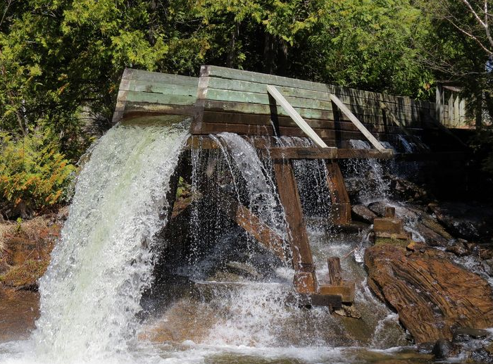
Curved Bridge
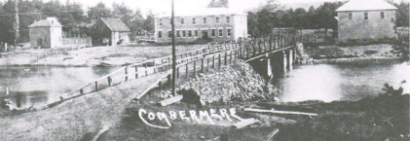
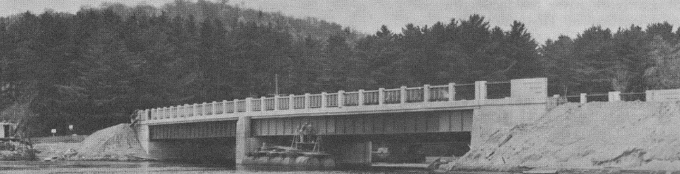

The first general store in Combermere was established in the 1850's by Daniel Johnson. In the 1920's Stafford 's store was purchased and operated by W. L. Waddington and continued until 1959 when it was demolished to make way for the new curved 285’ concrete bridge which was completed in 1960 for $320,000.
Farmers Market
Located at the corner of Highway 62 and Mill Road, the market operates from 8 a.m. until noon on Saturdays 613-756-5602
Geneva Replica
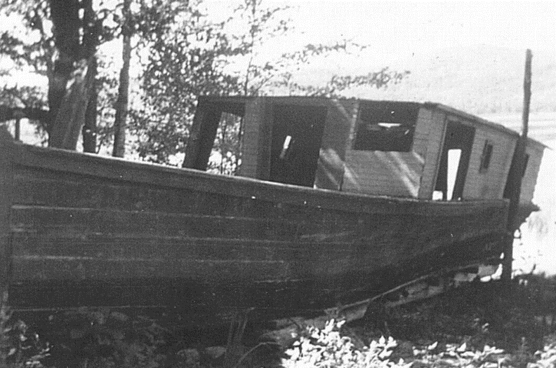
On display at Dennison Bridge Park, on the west of the bridge in Combermere is a replica of Geneva, pictured above in 1935. The steamer Geneva was one of the last steamers on the Madawaska River waterway. It was owned and operated by Starr Easton of Palmer Rapids and used to transport corundum from Craigmont and to tow boom logs to the mill. The remnants of the old scow sat for decades on property in Conroy's Marsh owned by the Enright family, who funded the boat's restoration and display.

Holy Canadian Matryrs Parish
(Formerly Sacred Heart Roman Catholic)
2797 Dafoe Road
The vestiges of the original church can be seen atop the hill, beyond the cemetery. Circa 1907.

Hudson House Hotel
B&B
1007 Mill Street
613-756-5908
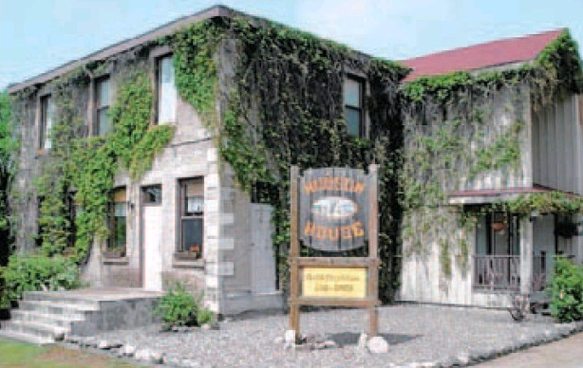
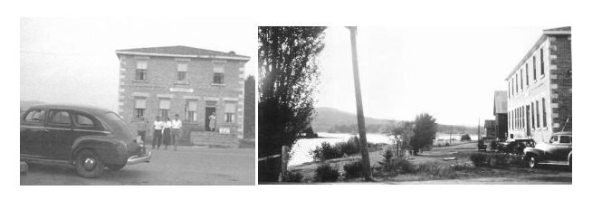
Elizabeth Dennison married John Hudson who had come out of England and in 1878 they took over the stopping place known as the Hudson House Hotel. John Dennison moved across the river and built a log house which stood there, until it was destroyed by a storm in 1951. John Hudson was the captain of the ill-fated Mayflower.
Hush Lodge
40621 Comberemere Rd (Highway 62)
Corrine & Gord Evely
613-756-8008
getaway@hushlodge.ca

Lodge and small cottages on Level Lake. Self-catering kitchen mid-May to mid-October.

Pine Cliff Resort
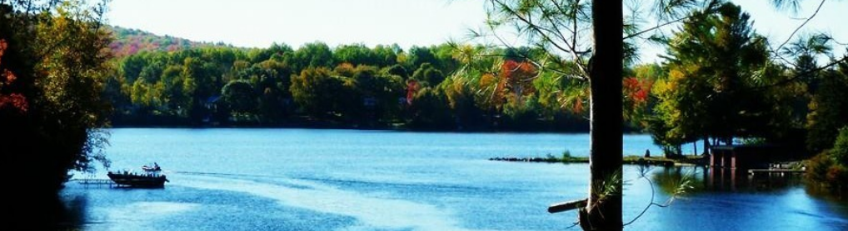
21 Allingham Lane
info@pinelciff.com
A four season resort on the banks of the Madawaska River & Kamaniskeg Lake in Combermere. 9 fully equipped cottages from 2 to 4 bedrooms, with all the necessities.
www.pinecliff.com
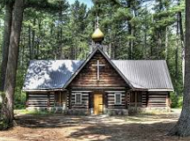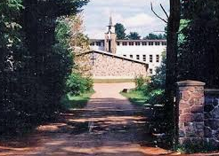

Madonna House Apostolate & Gift Shop
2888 Dafoe Road
combereme@madonnahouse.org
613-756-3713
Founded by Catherine & Eddie Doherty in 1947, Madonna House. It is a training centre for lay apostles and working guests from around the world, both Catholic and non-Catholic.
Daily tours are held at 11 a.m. and 2 p..m. and are 45 minutes. Tours include a visit to the Island Chapel, the grounds of Madonna House and Our Lady of Combermere. Tours end at the gift shop and museum which are open Tuesday through Saturday during the summer months.
The Madonna House Thrift Shop, St Joseph’s Clothing Centre is located at the intersection of Dafoe Road & Highway 62. It is open Thursdays and Saturdays 2p.m. to 4 p.m.
Also on site are crafts by Madonna House Staff, an Art Gallery, Used Bookshop
www.madonnahouse.org
http://www.madonnahouse.org/shops/
Mission House Museum & Gallery
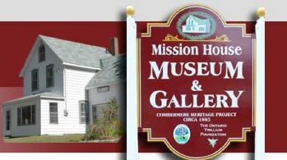
1050 Mill St
Combermere,ON
Wednesday, Thursday and Fridays from Noon to 4 p.m.
Adults $2, Children over 6 years $1, Under 6 years free
Family Pass $5
Celebrating the history of Combermere and surrounding communities. Of interest, on exhibit is a rare find that took place when crews were cutting down local trees that had been destroyed by an F2 tornado on August 3, 2006. More than 10,000 trees fell or were damaged by the storm Many of the trees were 150-plus-year-old white pines that had defined the town’s landscape. Cutting one such tree, the chainsaw wouldn’t make its way through, even with a brand new chain. Once they finally got it down, they discovered a winter horseshoe in the centre of the 160 year old pine. Had the chainsaw operator cut a few inches above or below that specific site, they’d never have found it.

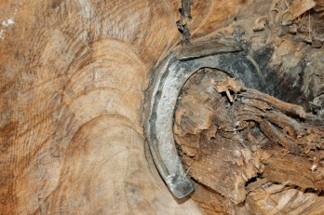
http://www.missionhousemuseum.com/
Opeongo Trail Resort
262 Ohio Road
613-585-1571
www.opeongotrail.com
A family-oriented resort on the 90 km Madawaska River System. Surrounded on three sides by the waters of Hyde’s Bay. Sandy beach. Canoes, boats, motor rentals. 6 Housekeeping cottages.

The Sinking of the Mayflower
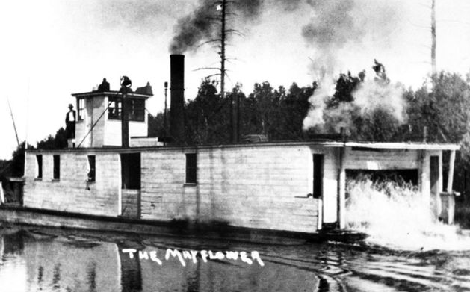
On the night of November 12, in 1912, the area lost an important link in the chain of communication and transport between Barry's Bay and Combermere. The Mayflower, a sternwheeler which had been carrying mail, passengers and freight went down in Kamaniskeg Lake, taking all lives on board with the exception of three persons who survived.
There have been many stories written about the sinking of the “Mayflower” boat on Lake Kamaniskeg on November 12, 1912 with three men surviving and nine people drowning.

The Mayflower was built on the shore beside the Hudson House in Combermere, ON in 1903 for two brothers, John Charles Hudson and Henry Edwin Hudson. She was built from oak, hemlock and local pine and was launched and commissioned in 1904. Her official registered number was 116861, gross tonnage of 58.86 and net tonnage of 38.02, length was 77', breadth 18', depth of 4' and height of about 20'. It was almost a flat bottom wooden boat designed with shallow draught for navigating the shallow waters over some shoals and sand bars on the Madawaska and York Rivers. Two cross compound steam engines mounted amidships 3 1/2 ft. below the deck powered her. J & R Weir of Montreal. Weir designed the Mayflower. The single rear paddle wheel was set into a cut in the stern and had twelve paddles. By the year 1912, the boat was not seaworthy and was not certified by the authorities. She had a previous sinking when it ran into a log “dead head” on the Madawaska River and partially sunk the year before. The boat had not been well maintained in the previous few years. She was built mainly to haul corundum from Craigmont across Kamaniskeg but also routinely transported passengers (although John Hudson was not licenced to do so).

The Mayflower was used for freight, mail and limited passenger service between Barry’s Bay and Combermere, Palmer Rapids on the Madawaska River and Havergal on the York River. It also serviced the corundum mines at Craigmont in the Conroy Marsh waterway. She was not an elegant boat, 70’ long, she had a clapboard pilot house and a noisy paddlewheel at the stern.

She had a crew of three - owner/Captain John Hudson, pilot/wheelsman Aaron Parcher and fireman/engineer Tom Delaney. It had no running lights and was not designed to be on the water at night. On Tuesday, November 12, 1912 the Mayflower had made what was to be the last return trip from Combermere to Barry’s Bay for the season but a local Combermere Councillor, William Boehme persuaded Captain John C. Hudson to make a second trip later that day to pick up the body of a brother-in-law, John Brown, from the Grand Trunk Railway station in Barry’s Bay to be buried in Fort Stewart before winter. John Brown died as a result of a gun accident in Saskatchewan. There were twelve people plus the casket onboard the boat when she left Barry’s Bay. The life boat, a 28 ft “pointer” the same used by Ottawa Valley lumbermen had been left behind on this last voyage as it had drifted way on the first trip of the day, retrieved and left tied up at the dock in Barry’s Bay. Another incident that day was the Mayflower bumping into the ship Ruby at the dock in Barry’s Bay but the crew were able to push the Mayflower off the Ruby with little damage to either boat.

The boat normally operated at about 5-7 miles an hour and had left Barry’s Bay at about 7:00 p.m. The trip from Barry’s Bay to Combermere normally took about 3 hours. It was a very cold November night with high winds but bright stars were shining when they left the wharf. It began to snow at about 9:00 p.m. and between what is now called Mayflower Island and the shore (about 40% to the island and 60% to the shore), the boat sank quickly for no apparent reason without warning. If she had provided some warning to the Captain and had another 30-60 seconds, she probably could have made it to shore which was about 600 feet away and everyone may have survived. It has been suggested that she went down for several reasons; (1) poorly maintained, (2) too shallow a draught and therefore subject to rough waves coming over the bow, sides and rear into the interior of the boat; (3) not being certified by the government agency; (4) the snowy, windy, cold weather that night; (5) pilot Aaron Parcher was not properly certified to operate the boat at that time with the required Master’s Certificate; (6) the modification to the paddles of the paddle wheel; (7) Oakum (caulking) disintegration between the ship boards; and (8) no cargo on bow to provide proper boat balance. John Hudson was also Reeve of Radcliffe Twp at the time, known to like his drink and only 47 years old and Aaron Parcher was 26 years old.

The water level in 1912 at the point where the Mayflower when down was approximately 23 ft. The bottom is quite sandy with no rocks and no drop offs and less than a hundred yards from shore. The funnel, flagpole and two side posts with attached heavy cable were all out of the water. In fact, four men scrambled to the top of the wheelhouse and were waist deep in cold water. They clung onto the floating casket and set out to the island about 500 feet away which took about 2-3 hours due to the cold, windy and high waves. The rest is history as Ripley wrote at the time as ”a dead man saves three lives”. The other eight passengers [William Boehme (58), George Bothwell (27), William Murphy, Robert Pachal, Mrs. William McWhirter (80)] and crew [John Hudson, Aaron Parcher and Tom Delaney] drowned.
Thomas P. Murray Recreational Trails

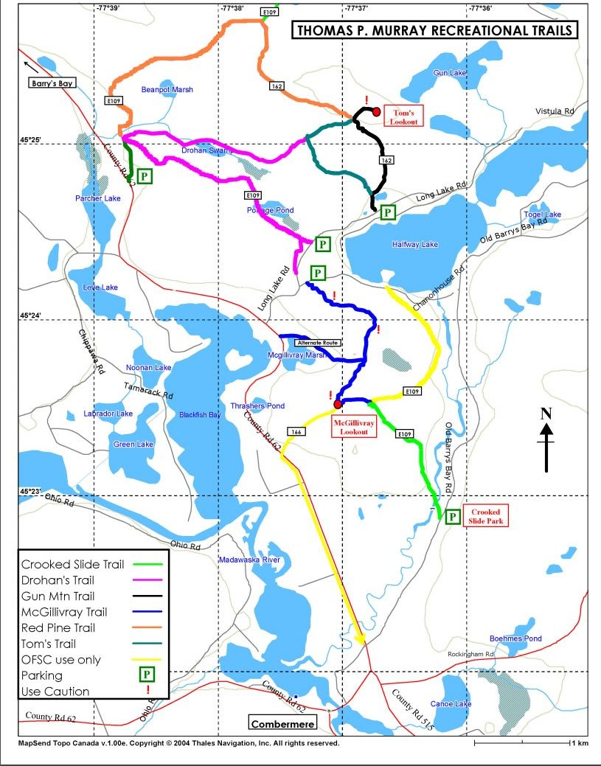
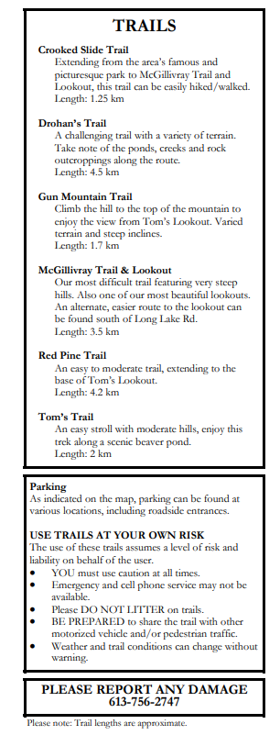

CONROY MARSH 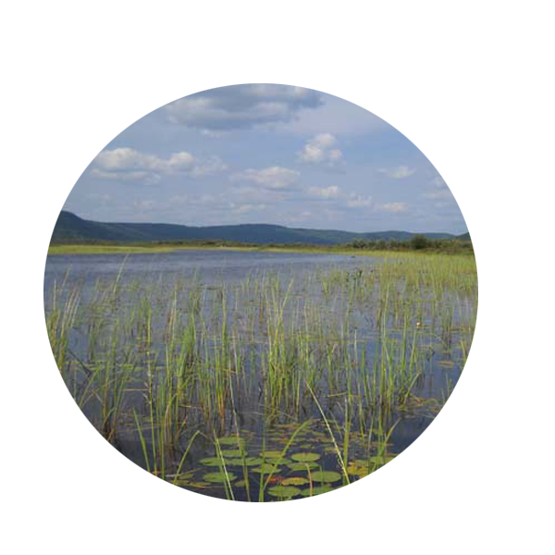
In Slabtown there is a public docking area at Trails End, off Boulter Rd. This access route is landlocked by the Slabtown rapids, but you can still access Egan Chutes by travelling up-river from this point. For ghost town enthusiasts, stories passed down from generation to generation tell of men who drowned in logging accidents near this boat launch. And there are rocks along the shoreline where the names of deceased log drivers have been etched in rough.
The Trails End portage extends 0.5km into Slabtown, ending at the iron bridge on Boulter Road. Slabtown once boasted an iron bridge, with high symmetrical railings, that fortified the structure. This new seventh bridge is a single-lane bridge, like those at New Carlow and the Little Mississippi, both surrounding tributaries that intersect with the York and Madawaska Rivers.
Conroy’s Marsh is approximately 10km, down river from Slabtown and it is the little known jewel of the York, described by some as a “Northern Bayou” because of its marshy bogs and lush vegetation.
Historically Conroy’s Marsh was a booming shanty town and an Alligator Boat brought tourists and prospectors to a hotel that once thrived there. The dilapidated remains of this Octogonal hotel provides a ghost town destination and an old roof can still be found on this property. These and other aging structures offer insights into the activities of a community that is long gone, but not forgotten.
As it turns out, bullfrogs also thrived in the Marsh and many years ago locals would trap and harvest them, putting their legs on ice before exporting them to posh urban eateries as far away as New York City.
Conroy’s Marsh is now a registered walleye spawning site and thick, pulsing schools of this fish literally overtake the water in April and May annually. In the fall the wild cranberries are so plentiful that you need only to strike the branches up against the boat to find your canoe 4 inches deep in the berries. Arts connoisseurs will recognize Conroy’s Marsh in A.J. Casson’s paintings titled by this same name.
The river continues adjacent to Highway 515 through Combermere, where it hits the Ottawa River at Arnprior, but this is where our story stops. But the river doesn’t stop, and if you are so inclined, it's just a matter of time before your canoe will reach the Atlantic.
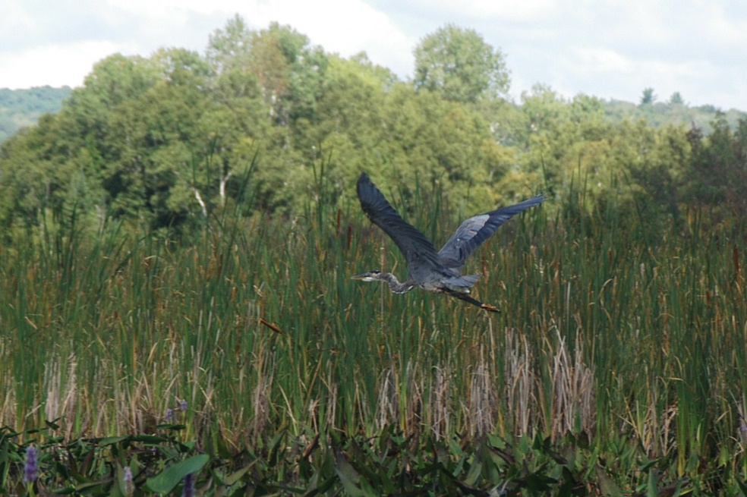
CRAIGMONT
Just off a quiet country lane, east of Combermere is the proximity of the historic Craigmont Corundum mine, now a ghost town. Mineral collecting here is quite remarkable. The corundum that is found is of a bronze/black colour and often in large crystals. They are known to display a star lighting effect. Incidentally, sapphire and ruby are the gemstone expressions of corundum.