DELORO
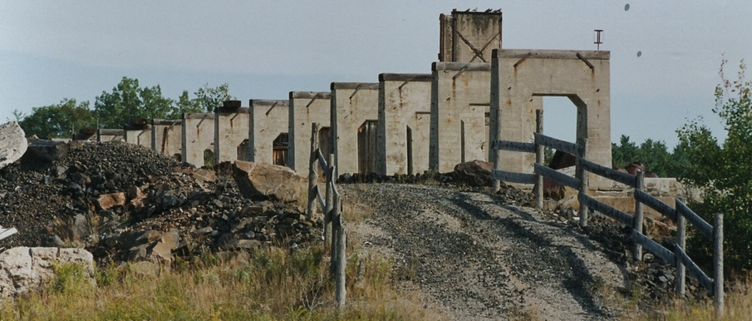
The name Deloro means valley of gold and that’s exactly what was discovered here, along the banks of the Moira River about 120 miles southwest of Ottawa in 1868. Mining operations began in 1873 and built a mill in which they used a cyanide process to extract gold and roasting furnaces which removed arsenic from the gold. The poor quality of the gold resulted in closure of the mill in 1903 but the arrival of the railroad the following year opened up new possibilities.
By 1916, the Deloro mining company had started building homes and schools for its employees and their families. The town had water and severs before Madoc or Marmora did. Known as a sporting community, the company supported baseball, hockey, tennis and lawn bowling teams.
Production of stellite, arsenic, silver and cobalt continued until the mid-fifties and silver was treated until the plant closure in 1961. The environment impact was significant. About 100 years of hazardous waste was left behind, contaminating the soil and water. Forty-five company owned homes were sold off for $900 or less, each. The village has been tested for gamma radiation and while a handful of locations have elevated levels, they are still well below provincial standards.

