DENBIGH
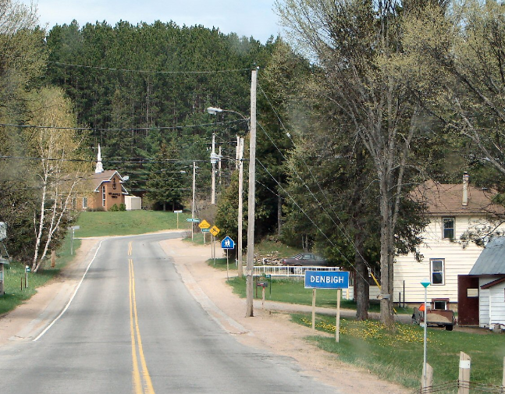
Denbigh, near the intersection of Highways 28 & 41, was settled in the mid-1850s in an area known as the Cedar Lake Settlement. Now known as Addington Highlands, in the County of Lennox and Addington. Addington Highlands contains Kaladar Pine Barrens Conservation Reserve and is near Puzzle Lake Provincial Park. This area was first settled following the construction of the Addington Road in 1857. It was originally named Scouten after its first postmaster. The old CPR rail bed passing through the town has become part of the Trans Canada Trail.
The township comprises the communities of Addington, Bishop Corners, Caverlys Landing, Cloyne, Denbigh, Ferguson Corners, Flinton, Flinton Corners, Glastonbury, Glenfield, Kaladar, Massanoga, McCrae, Northbrook, Rose Hill, Slate Falls, Vennachar, Vennachar Junction and Weslemkoon. The township's municipal offices are located in Flinton. Kaladar is located at the junction of Highway 7 and Highway 41. Bon Echo Provincial Park is located primarily in Addington Highlands.
BON ECHO “Mazinaw Lake” PICTOGRAPHS
With the exact etching dates still unknown, the 250+ pictographs on over 65 cliff surfaces along Mazinaw Lake at Bon Echo Provincial Park is widely recognized as one of the oldest First Nations pictograph sites in the Canadian Shield region.
Massanog, Massinaw, Mazinaw …no matter how you spell it in English, the roots of the word lie in the Algonquian language of those who came to this lake over a time span measured in millennia. Meaning something like “painted image”, the lake gets its name from the close to three hundred ochre rock paintings put there by Ojibwe or other Algonquian-speaking people three or four hundred years ago or perhaps even longer. Their canvas? Three kilometers of awe-inducing vertical pink granite cliff face with heights of up to one hundred meters. Mazinaw Rock has the largest single collection of pictographs in the entire Canadian Shield area.
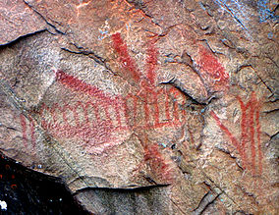
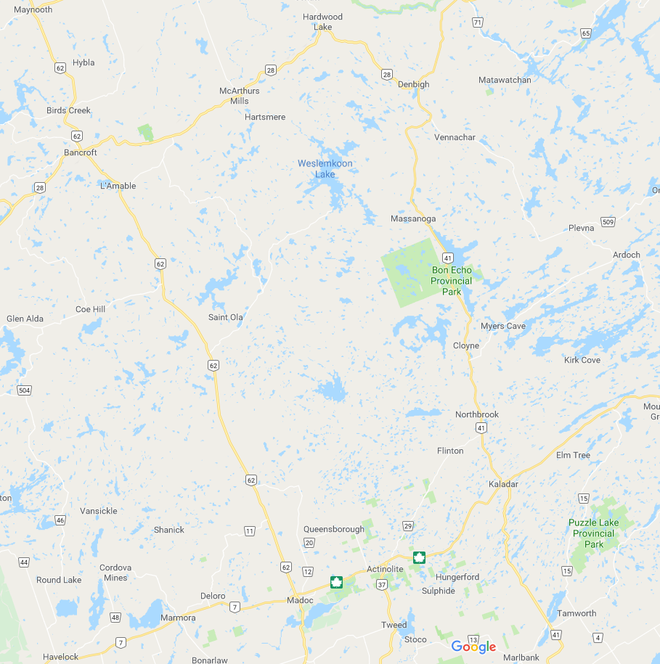
Bon Echo Provincial Park is a provincial park in southeastern Ontario north of Kaladar, approximately 6 kilometres north of Cloyne. Bon Echo features several lakes, including part of Mazinaw Lake, the seventh-deepest lake in Ontario. 16151 ON-41, Cloyne, ON K0H 1K0

