BOULTER
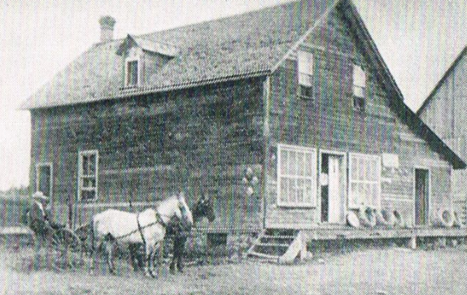
Boulter General Store 1908
The extraordinary hills you see in Boulter & McArthur’s Mills are actually the roots of the Grenville Mountains which once rivaled the Himalayans but eroded in the late Precambrian. They once. Geologically speaking, you could look at the area as “ground-zero” for the last major earth changes and that’s why there are so many different minerals found in the area.
Boulter was first settled in the 1840s, but has remained a quiet rural community with vast expanses of wilderness to explore.

See also: Burgess Mines, Conroy’s Marsh, Craigmont, Slabtown
A & R Country Kennel
Amy Dillabough
613-332-6232
98 Stringer Rd
McArthurs Mills
Non-shedding poodle crosses, registered breeder, licenced kennel.

Bee Kind Organics
www.beekindorganics.ca
Andrew MNcAlpine
95 Kennedy Road
613-334-0747
Organic family gardens, bee hives, maple syrup. 100% beeswax candles, natural soaps, medicinal ointments as well as 100% essential oil perfumes.

Benaaron Guest House
Ron & Elaine Wannamaker
5281 Boulter Road
613-332-0892
Relaxed & refined. Extraordinary views.
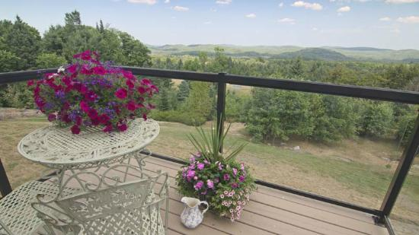
http://www.benaaronguesthouse.com/
Carriere Natural Gardens
3940 Boulter Road
Bernard & Renate Carriere
613-332-0130

Dreamer’s Rock B & B
Laura Smith & Gary Finlay
613-332-2350
35556 Highway 28 McArthurs Mills
Overlooking the rocks at the waterfall.
http://www.dreamersrockbandb.com/BBwelcome.html

Fraser Lake Beach
Whytes Road, Boulter

Little Mississippi Inn/Restaurant
Brenda McCauley
613-332-4717

Little Mississippi Trails Campground
Ron Chadband
98 Thaeter Lane
(Boulter Road to Haryett Road)
613-332-5106 evchadband@rogers.com
Open Victoria Day to Thanksgiving
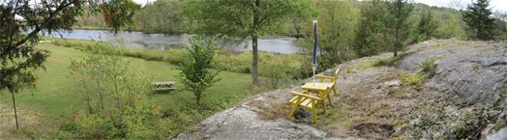
http://www.campingbancroftlmt.com/

McArthur Falls
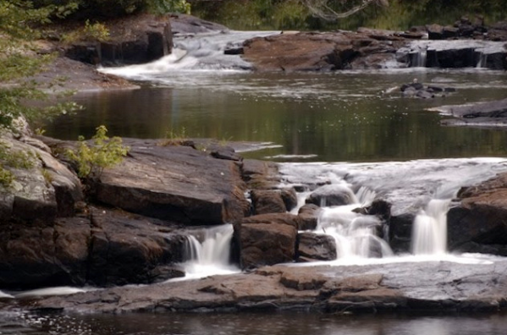
Visible from the roadside, on the Little Mississippi River, a wide cascade with a great deal of crown land surrounding.

Perfect Puppies
Irma Dillabough
613-332-3975
35345 Highway 28 McArthurs Mills
Specializing in poodle mix puppies
Pine Cone Forest Nature Sanctuary
A nature friendly retreat on the Upper Conroy Rapids is the ideal retreat for those wishing to escape the hectic pace of city life. Guided paddles, interpretive nature walks, cottage rentals, rustic camping. 150 acres of forest, blueberry meadows, wetlands and direct access to Conroys Marsh. Woodland trails, cranberry bog and lichen beds.
613-332-3651
Gus Zylstra
http://www.pinecone.on.ca/FOREST/index.html
Rockfield Farm
720 Hass Road, Boulter
Carlineg1958@gmail.com
613-332-5423
Operated by Cec Andrus & Carline Stamp
Organic vegetables, flowers, herbs and other produce. Jams, pickles, Dexter beef cattle. Sleigh Rides.
https://www.harvesthastings.ca/rockfield-farm
Silgrey Rustic Resort
1011 Havergal Rd
Mike & Wanda Wood
613-332-6359
A registered Walleye spawning site (mid-April to mid-May). A small collection of cottages. Direct access to the Conroy Marsh. Excellent walleye, bass and pike fishing. A great place for natural photographers, bird watchers and canoeists. Boat and motor rentals available. Canoes available with cabin rentals. Boat launch and docking on site. Pet friendly.
www.silgrey.ca

