CLOYNE
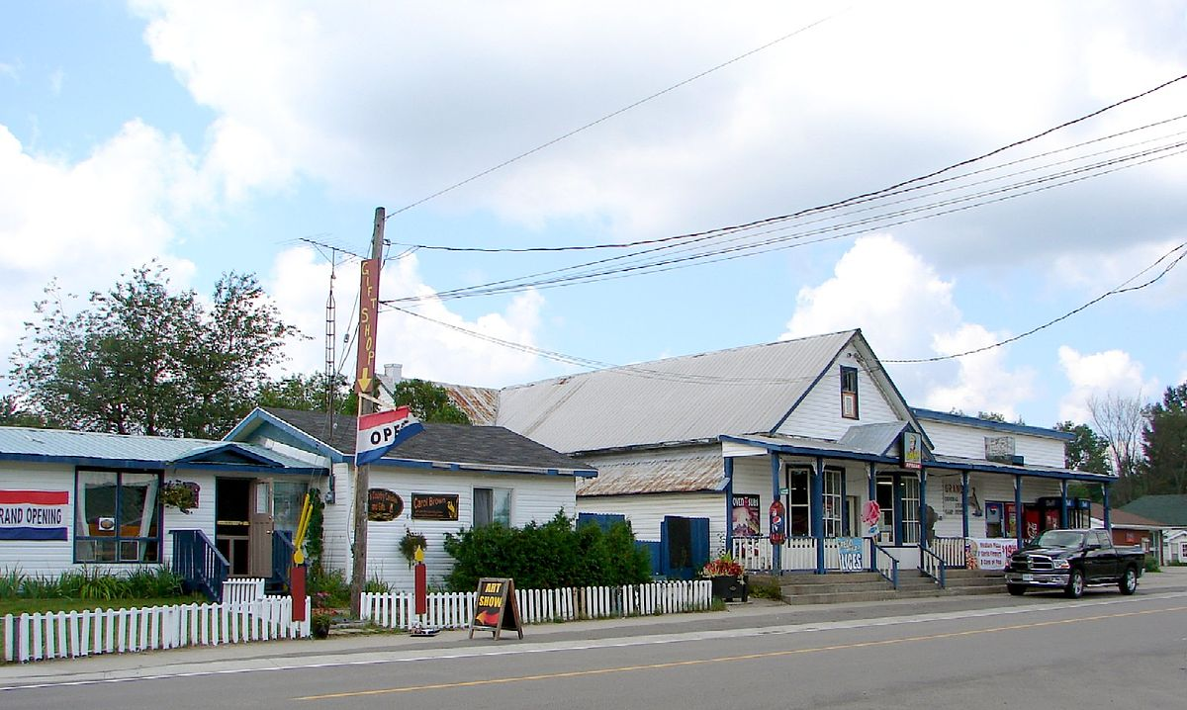

Cloyne is a small village in the township of Addington Highlands, Lennox and Addington County, Ontario, Canada. It is located on Ontario Highway 41 about 20 kilometres (12 mi) by road north of Kaladar at the crossroads of Highway 41 with Ontario Highway 7, with the settlements of Bishop Corners and Northbrook in between, and 43 kilometres (27 mi) by road south of Denbigh, with the settlements of Ferguson Corners and Vennachar Junction in between.
Cloyne Pioneer Museum and Archives
Highway 41, Cloyne
(Across from the Post office)
Daily in July and August from 10 a.m. to 4 p.m.
Note: not far from Mazinaw see also Bon Echo

