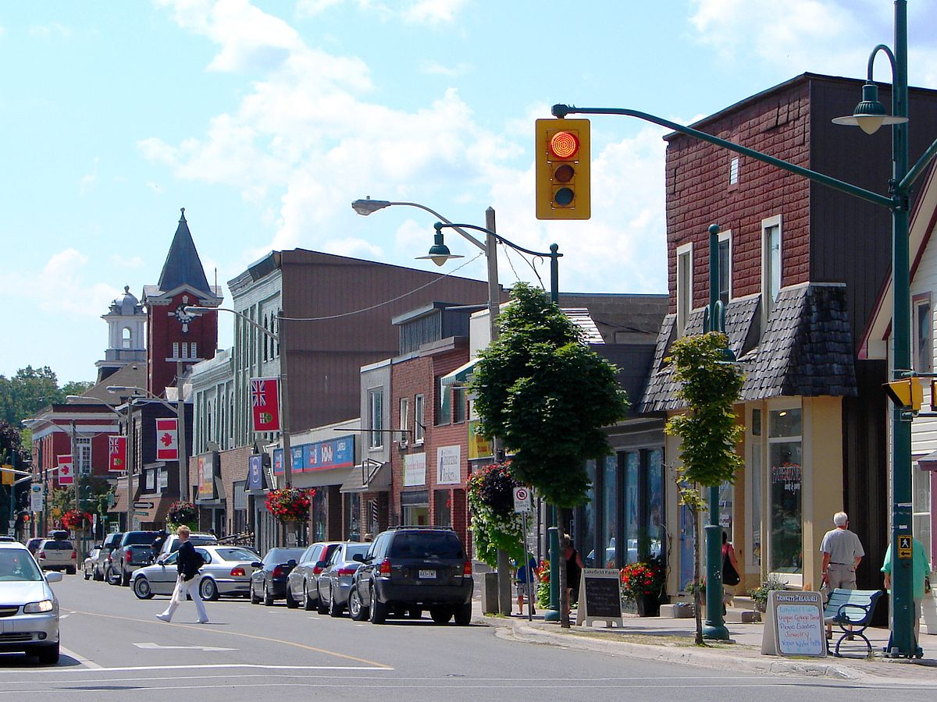

ENNISMORE
The Hamlet of Ennismore is historically picturesque with the post office, general store, and community church centrally located as in the days of old. Ennismore is centered in a mainly rural area, and provides a focal point for community recreational and social events including hard and softball diamonds, soccer pitches, tennis and basketball courts, ice and curling rinks and reception facilities. Chemong Lake, Buckhorn Lake and Pigeon Lake border the Ennismore ward. The Ennismore Waterfront Park and Beach covers 50 acres on Chemong Lake. With a beach, large picnic area, pavilion and the Heritage Trail, it is a satisfying recreation area for all ages. Ennismore is in the Township of Selwyn.

