LAKE ST PETER
Established in 1912, the community of Lake St Peter was originally known as Porterville but it was renamed in 1940 to coincide with the Central Ontario Railway stop at the shore of the nearby lake.
In 1956, a scenic park was established at a point of land that divided upper and lower Lake St Peter. The lake is known for sandy beaches. There are trails and public beaches. At the Lake St Peter park there is a public day use beach and another one, beside the trailer park, across from what was once the home of Esmond A. Skidmore, an eccentric musician, painter and novelist who operated an incredibly strange little tea room from his home, which was decorated with his own original paintings, some of UFOs and aliens that he claimed were drawn from personal experiences.
http://esmondart.tbglobal.net/
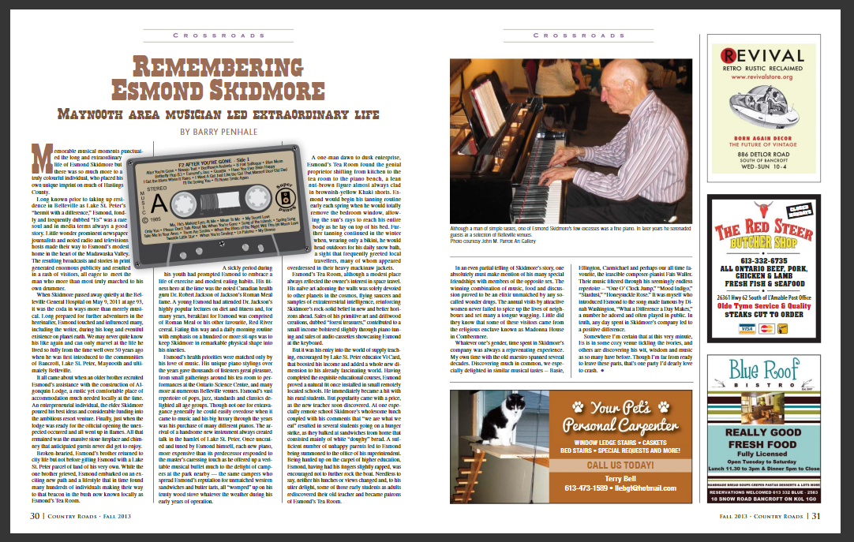
https://issuu.com/nancyhopkins/docs/cr13-03final
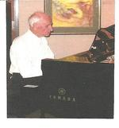
SKIDMORE, ESMOND ASTLEY of Belleville, formerly Lake St. Peter. December 26, 1917 - May 9, 2011, in his 94th year. Esmond slipped away peacefully in his sleep at Belleville General Hospital-QHC after a very brief illness and after enjoying a long wonderful and interesting life.
Survived by Sister Gwen Kemp of British Columbia, son in-law Brian Caldwell of Peterborough, three grandchildren Ian, Mary, David and great granddaughter Viola.
Predeceased by daughter Esther Caldwell.
Esmond wrote the following for you to read now:
I lived on the earth
A good many years,
I had lots of joy
And a great many tears.
Then came the time
No longer to roam,
I moved from the earth,
At last I'm back home.

Another eccentric local was Joe Goulah, who moved to the area in the 1920s, likely in the lumber business. Making his home in a small cabin, on nearby Mink Lake, he had a hermit-like lifestyle and a lot of pets. At one time, it is said that he had a pet racoon, chickens, ducks and a pack of 14 dogs.
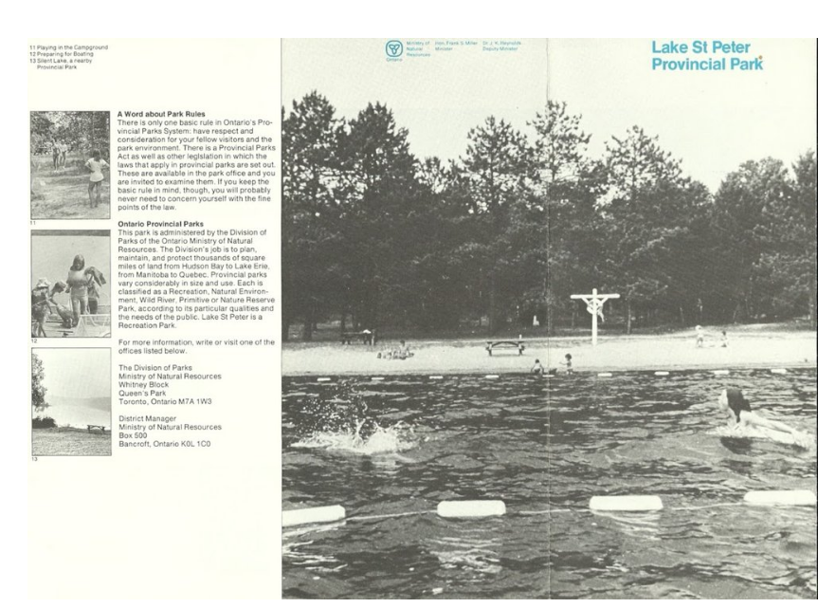
http://www.countryroadshastings.ca/featured-articles-seed/2017/9/21/the-hermit-of-lake-st-peterole-joe-goulah-lived-on-his-own-terms
https://www.ontarioparks.com/park/lakestpeter/facilities

