BURGESS MINES
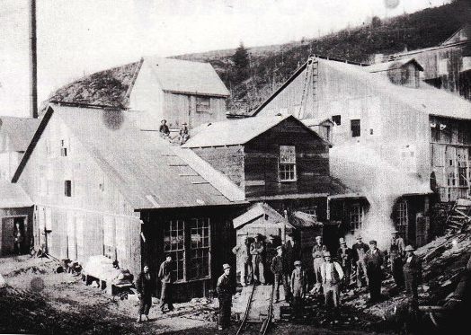
Burgess was the smaller, sister-town to Craigmont. In 1876, a young girl discovered crystals in the hill that looked much like large bottle stoppers. In 1902, the Ontario Corundum Company established an operation on the side of a mountain, Lot 14, Concession 15 of Carlow Township. More miners moved into Burgess after the 1913 fire that destroyed the mine at Craigmount. Corundum is a crystalline form of aluminium oxide. The mountain was worked in two sections and almost the entire hill has old dump sites, but the west slope is considered the best.
Directions from Bancroft, Ontario according to Mindat.org: First of all you would turn onto Highway 28 East. You would follow this highway for about 25.9 km until you encounter Boulter road past McArthurs Mills. Turn left onto Boulter road and follow it North for 17 kilometres until you encounter highway 517. Turn right onto highway 517 & go East for about 6.4 kilometers. At this point you should encounter Craigmont Road on the right. There will be no prior sign to the road so drive a bit slowly. Ok, now turn onto Craigmont road and follow it for about 2 kilometers. Always keep to the left when you follow Craigmont Road. After about 1 km into Craigmont road you will pass Regan road, keep to the left. On your left, through most of your ride along Craigmont road are hidden remains of the mine dumps, hidden in the bush. Anyway, after about 2 kilometers you will encounter a road turning sharply to the right, & there will be a house on the right in front of the turn. This is your indicator that you are getting close to the parking are. Continue to follow Craigmont Road straight, you will pass a marsh on your left. From this turnoff it is about 70 meters to the parking area, so drive slow. You will pass some woods on the right & left, and then there will be a small clearing on the left with what looks like the start of an ATV trail. You should park on one of the shoulders of this, do not block the trail entrance. This is the trail that goes to the mine. When you park make sure you leave enough room for cars to pass. It would also be a good idea to come during the weekday as the residence around the mountain don’t like visitors too much making noise on the weekend. Ok so you are here, the way to the mine is from the trail. As you start walking you will notice foundation ruins to the left and some structure to the right. These are the ruins of the mine mill. Other structure ruins can be located around the area of the parking zone. As you follow the trail it will go steadily up. Soon you will have 2 ways to go, the trail will keep heading up on the right, & down on the left. The left trail goes down the mountain to the adit, the right trail continues up and after a while it reaches the dumps. You can cut blindly forward of the T to make a shortcut to the dumps, but trails are always recommended so you don’t get lost. Right at the T you will see a small dug up area, you can start looking for Corundum bearing rock here.

