BARRY’S BAY
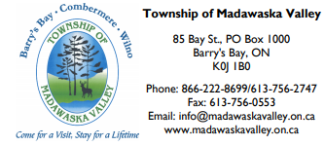
Located on the shore of Kamaniskeg Lake, this town was originally named 'Kuaenash Ne-ishing' (Algonquin for 'beautiful bay'). Settled in the mid-1800s, the name was to honour James Barry, a foreman for McLaughlin's Lumber in Arnprior, who constructed a cabin as his headquarters (in the area where St. Hedwig's Church currently stands). The town was officially incorporated in 1933.

Balmoral Hotel
16 Opeongo Square
613-756-5162
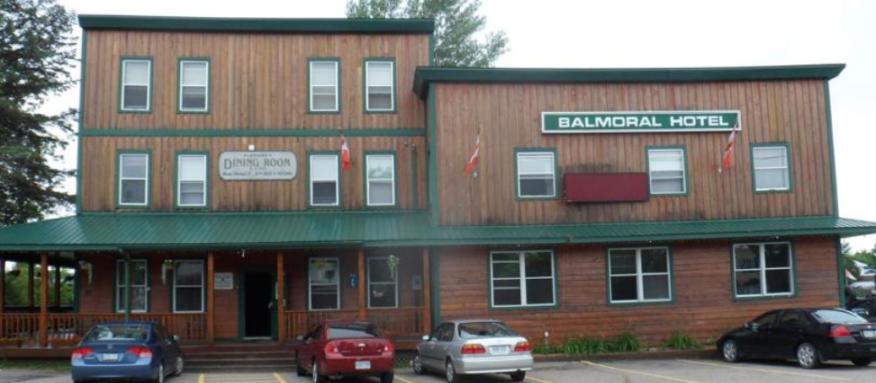

Originally called the Billings Hotel, the old hotel was built by Josh Billings. The building was destroyed by fire and rebuilt in 1899.

Gazebo (Band Shelter)
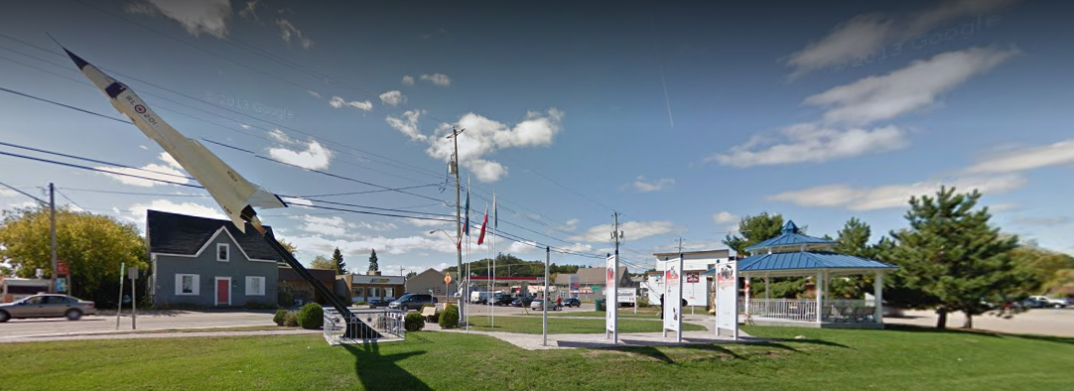
See: Zurakowski Park
Barry’s Bay Triathlon & Duathlon
http://www.barrysbaytriathlon.com/
Bay Day
Saturday, the May long weekend. The main street of town closes down for a street festival!
Farmer’s Market
Madawaska Valley Artisan Festival
Organized by the Railway Station Visitor Centre
http://www.southof60.com/
Madawaska Kanu Centre
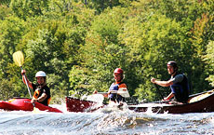
247 River Rd, Barry's Bay, ON K0J 1B0
1 888-652-5268
(613) 756-3620

Instruction in both kayaking and open canoeing. Lots of programs including weekend clinics, as well as a 2-hour whitewater raft trip on the Madawaska River or 5 day course.. Madawaska Kanu Centre is bike friendly. Cyclists touring, day riding, or out for a quick ride are welcome to stop by MKC. We have public washrooms, parking, and water to refill bottles while out riding. You can also enjoy the River Side Cafe. For an extra boost enjoy a latte, cappuccino, tea or baked treats. Madawaska has hosted an annual Thanksgiving Cycling Weekend for the past 30 years. If you are interested please let us know and you can join us to tour the valley and enjoy the fall colours.
http://owl-mkc.ca/mkc/
Paddle@mkc.ca
Madawaska Valley Studio Tour
Summer tour in July
Autumn Tour in September
http://www.madawaskastudiotour.com/
Old Railway Station
Visitor Centre, Art Gallery & more!
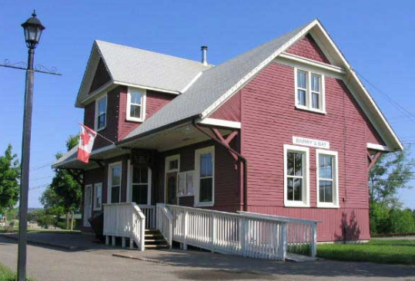
Omanique Beach Waterfront Trail
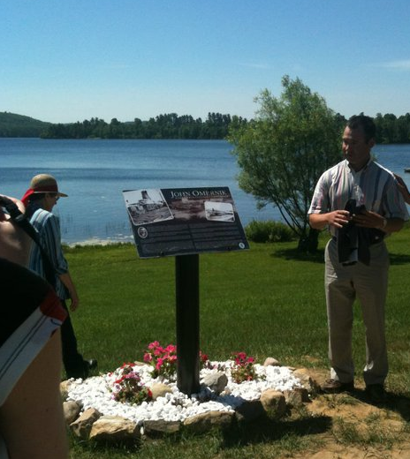
A Paved trail, 1l.5 kms long that winds its way along the Barry’s Bay waterfront.
Parking, picnic areas, washrooms on Kamaniskeg Lake. This is the launch site of the Barry’s Bay Triathlon.
Named after Joseph John Omanique.
In 1905, Barry's Bay was an active little community. Around twenty trains passed through it daily carrying passengers and lumber. Just three years before, Mick and Tom Murray had formed M & T Murray Lumber and they had now received their first timber limit. J.R. Booth, an Ottawa Valley lumberman, had been pulling his operations out of the valley since the 1890's due to the fact that the big stands of pine had almost all disappeared and the square timber trade was dwindling. A smaller, more localized lumber industry now took the place of the lumber baron's operations. M & T Lumber had their logs sawed at Martin's sawmill on Cybulskie's Pond. In 1911 they went into partnership with J. Omanique and by the winter of 1914 were employing about 150 men. This partnership lasted until 1929 and the following year saw the beginning of the Murray Brothers Lumber Company as we know it today.
In 1939, Omanique purchased the Canoe Lake Lumber Co mill (Algonquin Park, built in 1923) and operated it as Barry's Bay Lumber Co, though often referred to as Omanique Lumber.

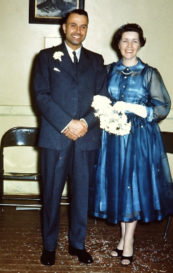
Joe & Violet
“Joseph John Omanique and Violet Mae Slominski”
http://www.ontariotrails.on.ca/trails/view/omanique-beach-waterfront-trail/
Our Lady Seat of Wisdom College
18 Karol Woytyla Square, Barry's Bay, ON K0J 1B0
(613) 756-3082
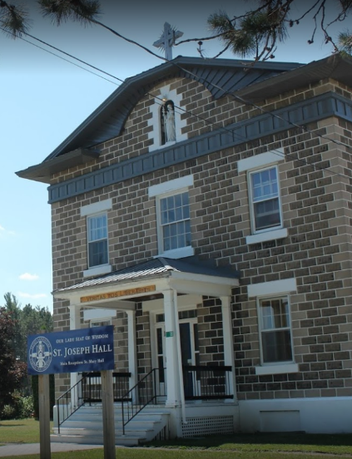
Our Lady Seat of Wisdom College, formerly Our Lady Seat of Wisdom Academy, is a Catholic post-secondary institution located in Barry's Bay.
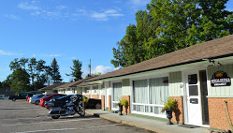
Pinewood Inn
278 John Street Barry’s Bay
613-756-1333
Family-run low-rise motel close town and the beach in Barry’s Bay.

St Hedwig Roman Catholic Church (1915)
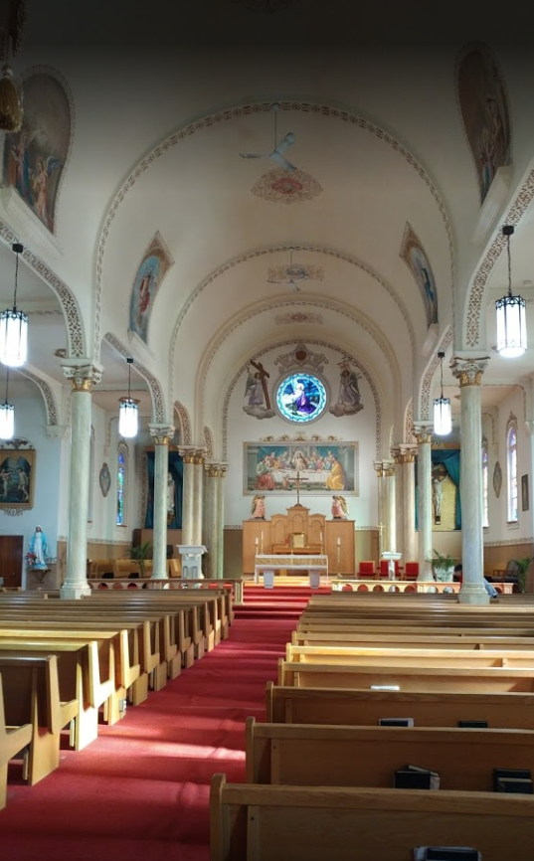
Located in Barry's Bay and area, in the heart of the Madawaska Valley, Ontario, we are proud of our rich cultural heritage -- Kashub, Polish, Irish, French-Canadian, Native, and a colourful sprinkling of other backgrounds from the human family
35 Karol Wojtyla Square, Barry's Bay, ON K0J 1B0
(613) 756-2243

St Lawrence O’Toole Roman Catholic Parish (1934)
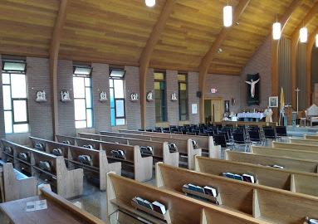
19450 Opeongo Line Barry’s Bay
(613) 756-2037

Taste of the Valley
Taste of the Valley is an exposition of local food, crafts and products that are produced by local residents. A community event to introduce both visitors and local residents to the many unique agricultural products available in the region in 2018, the event will take place on Friday August 17th at the Railway Station.
The Ash Grove Inn
42524 Combermere Rd, Barry’s Bay
613-756-7672
Restaurant and Motel overlooking Kamaniskeg Lake.

Wooden Water Tower
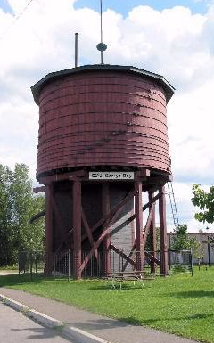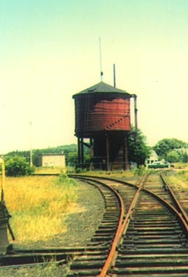
Built in 1894-1895, The Barry’s Bay Water Tower is most likely the only remaining wooden water tower in Ontario. Located off Stafford Street.
Zurakowski Park
85 Bay St., Box 1000
Barry's Bay ON K0J 1B0
Canada
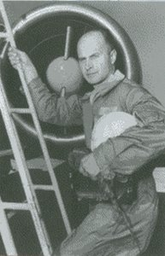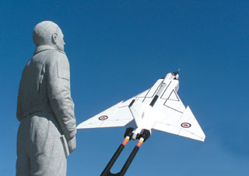
Zurakowski Park was officially opened on July 26, 2003. It honours local resident and world-renowned test pilot Janusz Zurakowski (a member of Canada’s Aviation Hall of Fame) who lived in the Barry’s Bay area from 1960, operating the Kartuzy Lodge with his wife Anna, until his death in 2004.
A Polish Canadian who has been at the forefront of cutting edge aviation technology, he was raised in Poland and joined the Polish Air Force in 1934. Zurakowski escaped to England in 1940 and flew aircraft in England and then, in Canada which became his home in 1952. The most notable aircraft he tested was the Canadian supersonic interceptor known as the CF-105 Avro Arrow. The park includes a shaded gazebo with picnic table (sometimes there are live bands playing there) and commemorative/informational installations.

https://www.zurakowskipark.ca/

