PAKENHAM
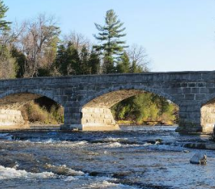
A small community known for its stone bridge that spans the Mississippi River. Built in 1901, the bridge is 268’ long, 22’ high and 25’ wide and has five arches that span 40’
Mount Pakenham
577 Ski Hill Road
613-624-5290 ski@mountpakenham.com
The place to ski during school breaks!
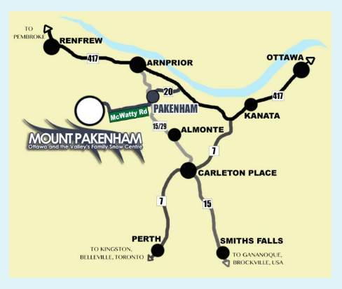
http://www.mountpakenham.com/
Pakenham General Store circa 1840
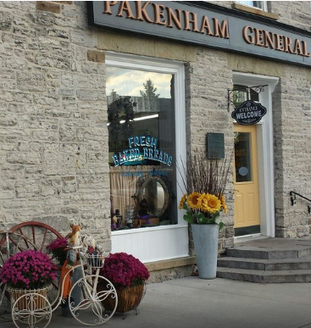
Enjoy a walk back in time at this store, nestled in the heart of the Mississippi Hills. Open continuously since it was established, the store maintains its original charm. The shop includes a gift boutique, art gallery, antiques, century furniture, artwork, fresh baking, groceries and ice cream.
St Peter Celestine Roman Catholic Church
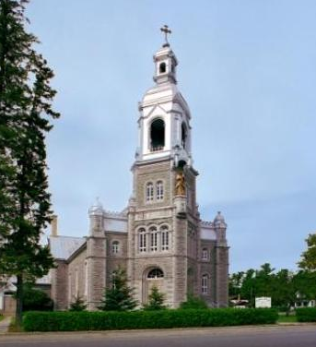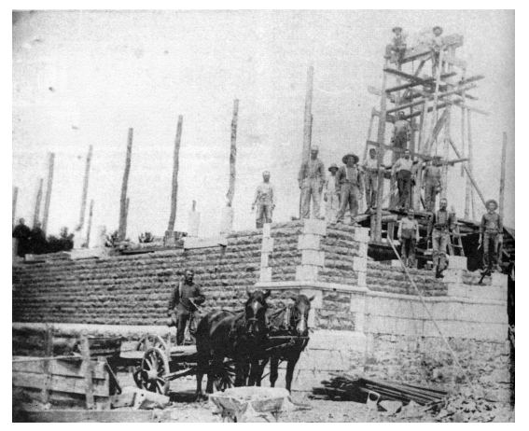
139 Renfrew Street 613-256-3441
www.stpetercelestine.ca
Mass on Saturdays at 6 p.m. and Sundays at 9:30 a.m.
Built in the French Classic Style and decorated with a Classic Italianate interior. The cornerstone was laid July 31, 1892.
Mill of Kintail
10970 Hwy 7, Carleton Place
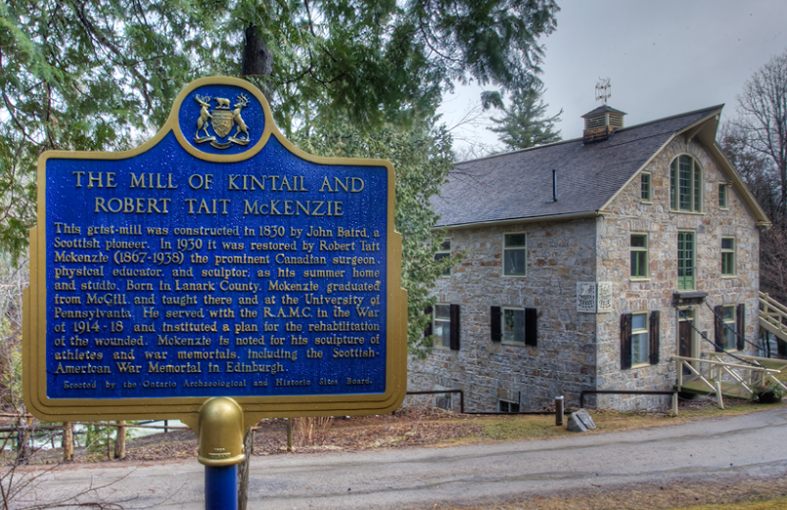
Trails are open year round, in all weather, 7 days a week from dawn to dusk. The R. Tait McKenzie and James Naismith Museum opens for the season on Saturday, May 19, 2018.
Monday-Friday 9am-3:30pm
Saturday-Sunday 10:30am-4:30pm
The Museum will open on Saturday, May 19, 2018.
Entrance Fees
$6.00 per vehicle
Call (613) 256 3610 or email skolsters@mvc.on.ca for more information about available rental facilities.

