KEENE
Lang Pioneer Village
Museum
104 Lang Rd, Keene, ON K0L 2G0 705-295-6694
An award-winning, living history museum in the hamlet of Lang, Ontario. Open spring May-June from 10 a.m. to 3 p.m. Monday-Friday and Summer June to Labour Day 7 days a week from 10 a.m. to 4 p.m.
Admission $10 for adults, $8 Students & Seniors 60+, Youth 5-14 $5 and Family Pass $30.
http://www.langpioneervillage.ca/
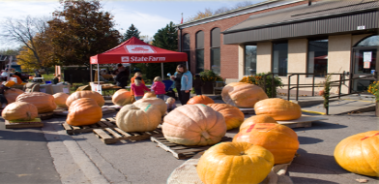
The Festival Centre is at the Lions Den
1137 Heritage Line in the Village of Keene.
http://www.thekeenepumpkinfestival.com/

