PAUDASH
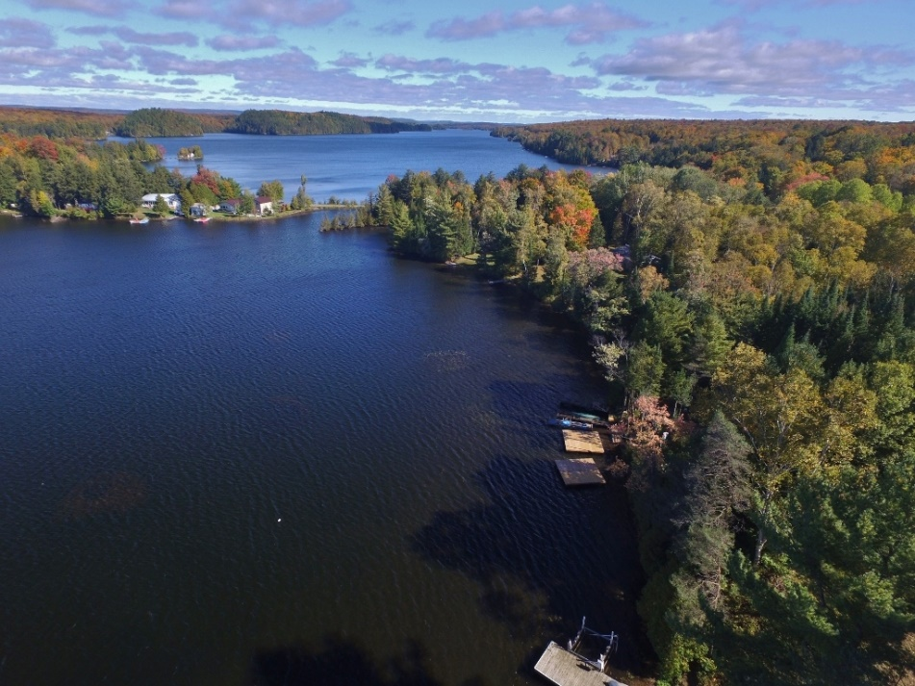
Image from Cottage Rentals 247: 73 Hastings St N in Bancroft 332-3340

A hamlet at the corner of Highways 28S & 118. Here you’ll find a motel and
Marina and Fun Times Water Sports Outlet. South of 118 is the Somerset Lakeside Resort and The Anchorage Resort is off McGillivray Rd. The Craftsman Restaurant on Highway 28 just north of 118. Just north of the Craftsman off Paudash School Road is Mystickal Paths New Age shop.

Beaches on Paudash Lake
North Bay features a public sand-bottom beach (with rest rooms) that can be accessed by car off of Highway 118 (via North Bay Beach Road) and by boat. The beach features a boat launching ramp and there is an annual regatta that takes place on the beach. Water-skiing and wakeboarding are available.
Paudash Beach is a sandy beach stretching 60-metres along the shores of Paudash Lake. At this beach you'll find washroom facilities, parking, and lots of grassy area
Just over 1.6 km (0.99 mi) away, Silent Lake Provincial Park has over 40 km (25 mi) of cross-country ski trails, featuring natural, wood-fired warming huts along the trails.
The Paudash Lake Conservation Association hosts a regatta/family fun day and rock bass derby annually.
A little History:
Paudash Lake was named after Chief George Paudash, a Crane-doodem (clan) member of the Chippewa (Ojibwa) Indians of the Hiawatha Reserve of Rice Lake. The immediate area was first settled by pioneer families in the early 1870s. One of the original families, the McGillivray's, are still part of the Paudash Lake community. In 1875, Malcolm McGillivray Sr. took a land grant of 1.2 square kilometres (300 acres) at Concession V111, a point of land jutting into Paudash Lake, and later built the first bridge over the narrows between the upper and lower lakes (by today's Anchorage Resort). While the first summer cottage was built on Big Island by the Johnson family in North Bay in the early 1920s, there was very little development on the lake, and indeed in Haliburton as a whole, until the late 1930s, when the two great access highways from the south were constructed. Highway 28 in the east, and Highway 35 in the west, with Highway 118 later connecting the two. The War then delayed development on the lakes, and finally in the late 1940s, development got under way.
From the 1880s to the 1940s there were commercial resorts in Muskoka and Haliburton that were accessible by railroad and boat, with local transport over dirt roads by horse and buggy and later, cars and buses. The uncoordinated and ill-advised attempts by the government to develop Muskoka and Haliburton between 1850 and World War II for other purposes were a failure, however, due to the area's general unsuitability for agriculture and industry.
Major cottage development on Paudash Lake got underway in the 1950s and continued through the 1960s. Today, the lake is largely 'developed' with 640 properties. Fifteen percent of the land on the lake is unoccupied, permanent 'Crown land', as well as one large island.
On November 5, 1818, the six Chiefs of the Chippewa (Ojibwa) Nation of southern and central Ontario, including Chief Paudash, sold and conveyed to the Crown what is today all of southern Muskoka and southern Haliburton (below 45 degrees north), for the "consideration of the yearly sum of Seven Hundred and Forty Pounds Province Currency in goods at the Montreal price". Chief Paudash's "mark" on the Treaty was, in accordance with the custom of signing as a representative of the Crane-doodem, a tiny stick drawing of a Crane (Public Archives of Canada R.G. 10, ser.4, v.2, Treaty No. 20.). The use of the Crane-doodem agrees with accounts that say the Chief who made the mark, probably George Paudash father of Mosang, and grandfather of Robert, was the last hereditary grand chief of the Missassaugas. The grand chief was derived from the chief of the dominant doodem. This is coincidentally interesting also because the crane image dominates the Petroglyphs at Stoney Lake in Petroglyph Provincial Park. It MIGHT suggest that the crane is a recent addition graphically laying claim to the site by the Ojibwa (or at least Mississaugas).
As with the Eels Lake and Jacks Lake south of Paudash, it was the practice of early settlers - when the Indian presence still had strength - to name lakes after the apparent dominant Indian clan or extended family patriarch or chief. Jack's Lake was named after Jack Cow and Eels Lake after Eel Cow. It follows that settlers experienced the visits now and then of the Paudash family at Paudash Lake and that was how the name was established.

