YOUNG’S POINT
With Clear Lake to the north and Lake Katchewanooka to the South, this tiny hamlet is home to Lock 27 on the Trent-Severn Waterway. Young’s Point is a busy place – the largest country store in the Kawarthas is located here and it welcomes over 100,000 visitors a year. One of the area’s finest kitchens, a 24-hour fitness centre, a general store with bakery and nearby cottage resorts round out this key destination. The Young’s Point settlement area is located in both the Township of Selwyn and the Township of Douro-Dummer, right at popular Stoney Lake.
Formally established in 1825, the village was named after the Young family who settled in the area and build a dam and grist mill. It is referenced in Susanna Moodie`s Book `Roughing it in the Bush`. Youngs Point is also the resting place of Polly Cow, the beautiful daughter of Handsome Jack Cow who was a close friend of the Youngs.

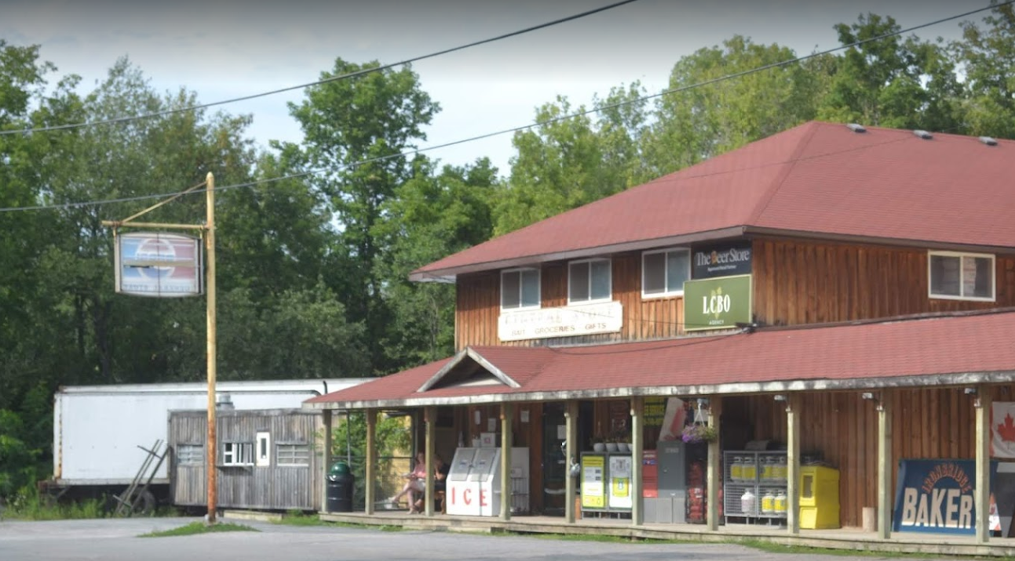
Young’s Point General Store- #2095 Nathaway Dr,-Young’s Point, ON K0L 3G0 (705) 652-3731

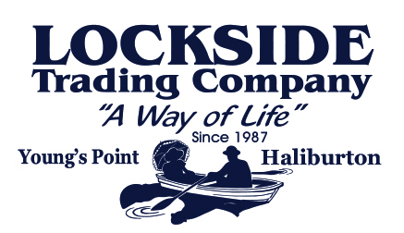
Lockside Trading Company 280-5 River Ave, Young’s Point, K0L 3G0 (705) 652-3940
Lockside began in 1987 with the purchase of the historic Young family homestead in the community of Young’s Point, Ontario (built in the 1850’s). It had been the lockmasters house at Lock 27 on the Trent-Severn Waterway, and the home of the The Stoney Lake Navigation Company a steamboat company that offered transportation for the area. Originally fashioned as an antique and gift shop, Lockside has grown into the largest country store in the Kawarthas, showcasing four seasons of in-store design and merchandise. Lockside is a full service retail store operating 362 days a year. Offering a constantly changing environment and experience the store has become a favourite destination for local and out-of-town visitors alike. Attracting more than 100,000 visitors a year, so many in fact, that in 1997 it was classified as an Ontario Major Attraction.
What began as a tiny, 400-square-foot shop has grown over the past 20 plus years to encompass more than 7,000-square-feet. The shop offers a mix of cottage and country items including giftware, decorative accents and home décor and features a wide selection of quality indoor and outdoor furniture, as well as comfortable clothing. Topping it all off with great services like the Design centre that helps customers in designing there dream home, to Steamer's Café offering everything from ice-cream, specialty coffees, to panini’s. It is the one stop shopping destination that everyone has to experience more than once.

