GLEN ALDA
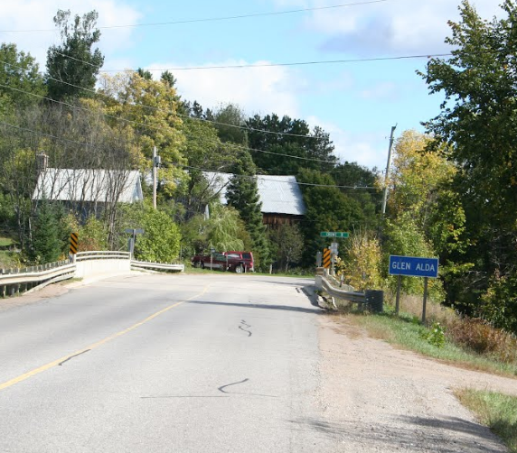
A century-old schoolhouse has been converted to a quaint community centre at 3723 County Road 620 in Glen Alda. There’s an outdoor picnic area and some playground equipment.

