TORY HILL
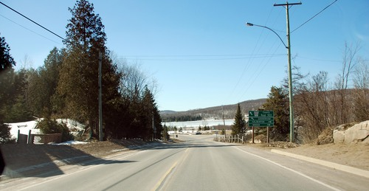
Situated on the shore of McCue Lake and the intersection of HWY 118 and County Road 503, Tory Hill’s location makes for the best fall colours in area, with views for miles. Once a booming village, it has some rare finds. The Tory Hill United Church is now a private residence, home to Artech Glass Studio; there is also Highlands East Nursery (where perennials and trees are grown for the area) and the Rideau Docks. At the Tory Hill Park you can access the multi-use IB&O Rail Trail that either takes you to Gooderham or to Wilberforce.
