BUCKHORN
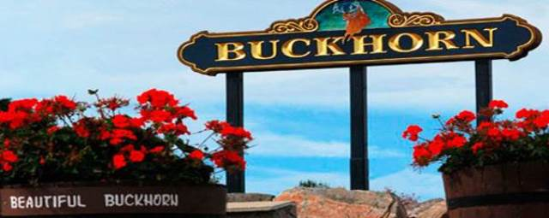

One of the busiest locks on the Trent-Severn Waterway is in the heart of Buckhorn. Anglers are drawn to the area for superior fishing year round. Several cottage resorts have welcomed the same families for generations. The Community Centre has an immensely active volunteer base assisting with over a dozen festivals and events each year. With their Buckhorn Fine Art Festival being named one of the top 100 festivals in Ontario, it’s not surprising that thousands flock to this event each August. A local winery can be found just minutes north. Just to the west is Sandy Lake and a popular public beach. Buckhorn is located in both the Township of Selwyn and the Municipality of Trent Lakes.
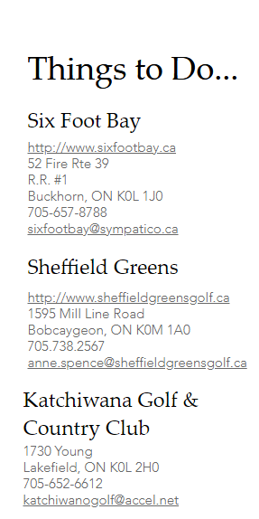
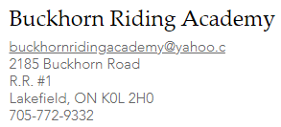
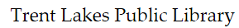
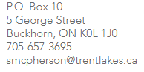
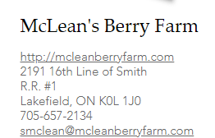
Farmer's Markets
Tuesday Buckhorn Farmers Market located at the Buckhorn Community Centre
​
Thursday Lakefield Farmers Market located in downtown Lakefield
​
Friday Bridgenorth Farmers Market located at the Paul English Lions Club Park
​
Saturday Bobcageon Farmers Market located in the Fair grounds parking lot
​
Saturday Peterborough Farmers Market located in the Fair grounds parking lot

OTHER Things to Do...

Warsaw Caves
http://www.warsawcaves.com

Silent Lake
http://www.ontarioparks.com/park/silentlake

Peterborough Zoo
http://www.peterboroughutilities.ca/Park_and_Zoo

Lang Pioneer Village
http://www.langpioneervillage.ca

Chemong Lakes Fishing Charters
http://www.kawarthafishing.com
bdaniels@kawarthafishing.com

Find Area Information at www.buckhorntourism.ca
Area Events:
https://www.buckhorntourism.ca/buckhorn-area-events

