APSLEY & Area
A very small settlement area, Apsley is the northeastern gateway to the Kawartha Highlands Provincial Park – the largest park in Ontario south of Algonquin and a very popular family cottage location. Chandos Beach to the north and Quarry Bay Beach to the south offer swim rafts, change rooms and swimming lessons. With many families having lived in the area for generations there is a strong sense of community. Apsley and area is in the Township of North Kawartha.
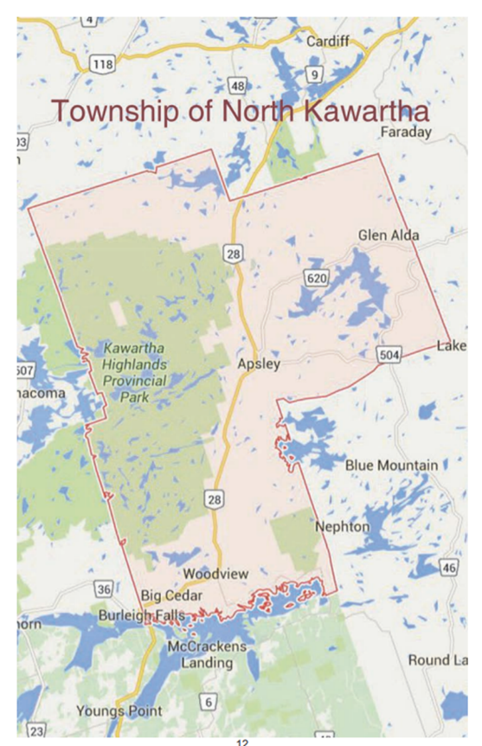
https://www.northkawartha.on.ca
http://www.apsley.ca/
Apsley Auctions: https://www.apsleyauctions.com/auctions/
Antiques, collectibles and unique items. Each auction is different depending on what has come in. The auctions are held at the North Kawartha Community Centre. Previews are at 8:30 am, the Auction begins at 9:30 am and concludes at 4 pm.

Apsley Market
The Apsley Market is open Saturdays 9 am until 2 pm, from Victoria Day (May 21) to Labour Day (September 03). The Market is located behind Hunter's General Store, at the back of the parking lot.

Chandos Beach
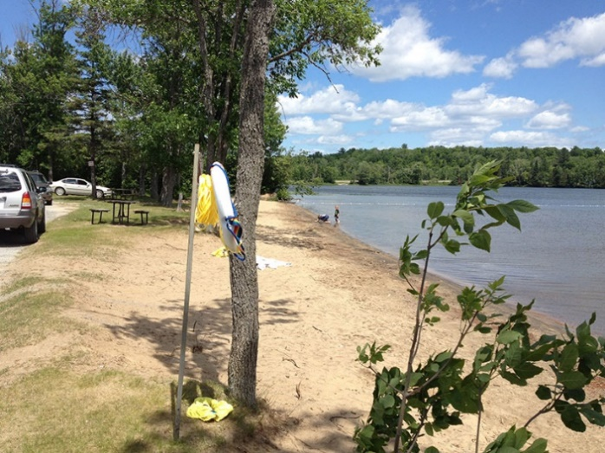
2821 County Road 620, Apsley, ON K0L 1A0, about 15 minutes north of Apsley.
- Large, grassy, picnic area
- Roped-off swim area
- Swim Raft
- Washrooms and change rooms
- Boat launch area nearby

Kawartha Highlands Hiking Trail:
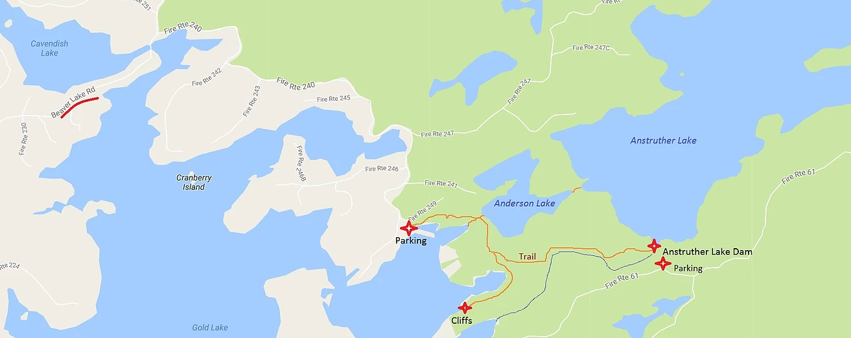
Ontario Parks has added a new 1.5km hiking trail to the Kawartha Highlands Signature Site Park. You can access it by heading to the Mississagua River takeout (just a few minutes North of Buckhorn, Ontario). Be sure to grab one of the little booklets that describe the history of the land, and point out unique critters that are local to the area. The area is nice and rugged so be sure to bring your hiking boots, and bring a lunch to enjoy along the edge of the Mississagua River.

Kawartha Highlands Signature Site Park

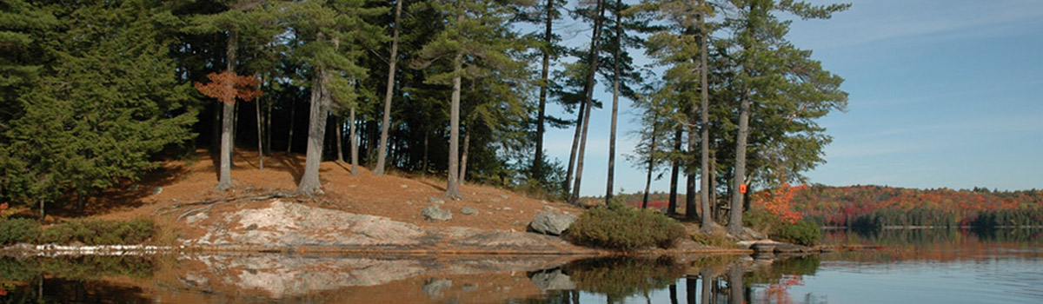

Kawartha Highlands Signature Site Park is the largest park in southern Ontario after Algonquin Provincial Park. Established in 1989, unlike some parks you may be familiar with, the access points at Kawartha don’t have a lot of facilities. There is limited parking.
Over 100 backcountry campsites spread over six recommended loops. Most sites have three tent pads, a designated fire ring, a picnic table and a privy toilet. Campsites can only be reached by canoe and most require portaging to access them; there are no car campsites in the park.
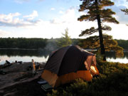

Ministry permits for camping and parking are now required.
Campsite Registration: You can reserve online at www.ontarioparks.com or by phone at 1-888-668-7275
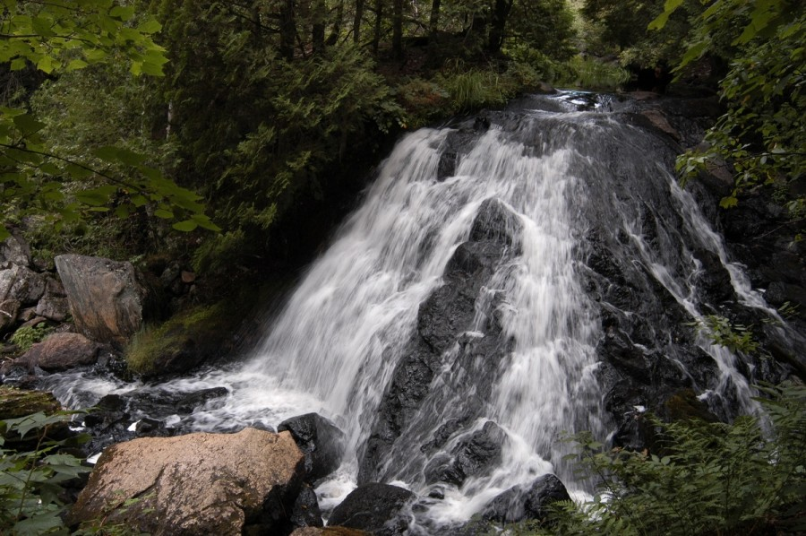

The area has some amazing water features and the Rathburn Lake to Copper Lake portage trail runs along the side of one of the most impressive waterfalls.
Sucker Lake Hike to Campsites:
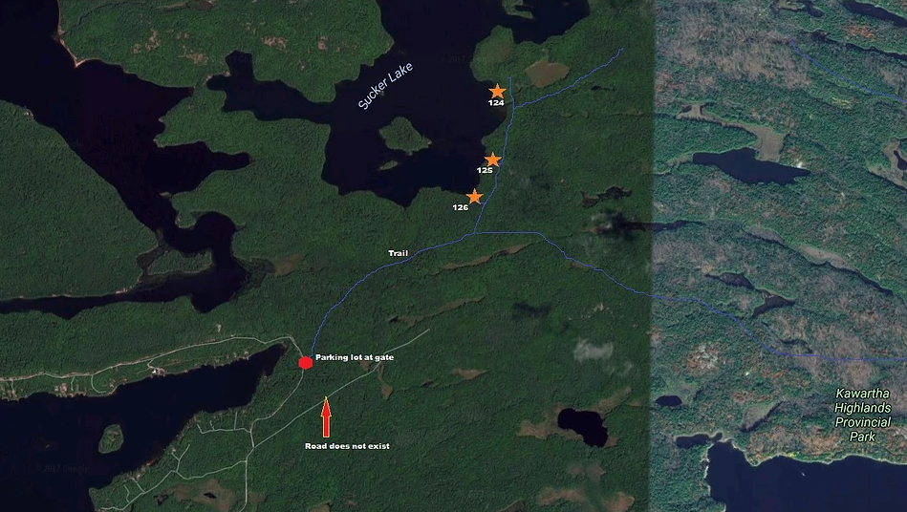

North Kawartha Community Centre
340 McFadden Road
Fitness centre, NHL sized arena

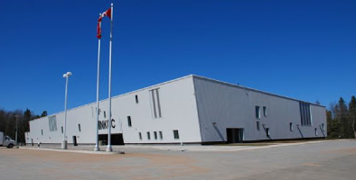
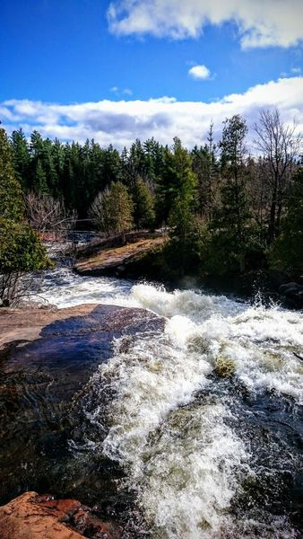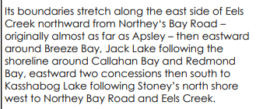
Peterborough Crown Game Preserve
Just south of Apsley, this area includes Jack Lake and is ideal for nature lovers, artists, photographers and cross-country skiers. The Crown Game Preserve is not a Provincial or National park and does not have access as such. Jack’s Lake among other lakes and Petroglyphs Provincial Park all fall within the Preserves boundaries. Many of these places offer tent and trailer park camping.

The initial 85.8 square mile (223 square kilometres) Peterborough Crown Game Preserve was formed in 1927 as part of a government theory: that if animals were protected in a game preserve they would multiply and provide a continuous supply of animals for hunting outside the preserve. Unfortunately over time it was learned that the animals put too much stress on the environment in the preserve and most of the game preserves were abolished except for 15 such preserves, the Peterborough Crown Game Preserve being one of these 15.

https://jackslakehistory.wordpress.com/crown-land-game-preserve/

Petroglyphs Park

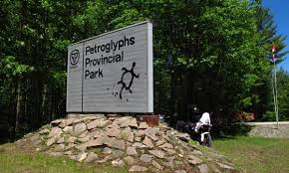
This is the largest known concentration of Indigenous rock carvings (petroglyphs) in Canada, depicting turtles, snakes, birds, humans and more; this sacred site is known as “The Teaching Rocks”. There are 600 to 1100 year old rock carvings that are the feature attraction in this park, which is about 21 km southeast of Apsley, at the end of Northey's Bay Road.
- Visit the Learning Place Visitor Centre to discover the traditions of the Ojibway (Nishnaabe) people through the teachings of the medicine wheel
- Visit bright blue/green McGinnis Lake – one of only a handful of meromictic (layers of water that don’t intermix) lakes in Canada
- Great opportunities for wildlife viewing

Open daily 10:00am - 5:00pm (No vehicle access after 4:30pm. All vehicles must exit before gates close at 5:30pm). The park is closed on Mondays and Tuesdays in the Spring and Fall with the exception of Holiday Mondays.

https://www.ontarioparks.com/park/petroglyphs

Stoney Lake Cruises
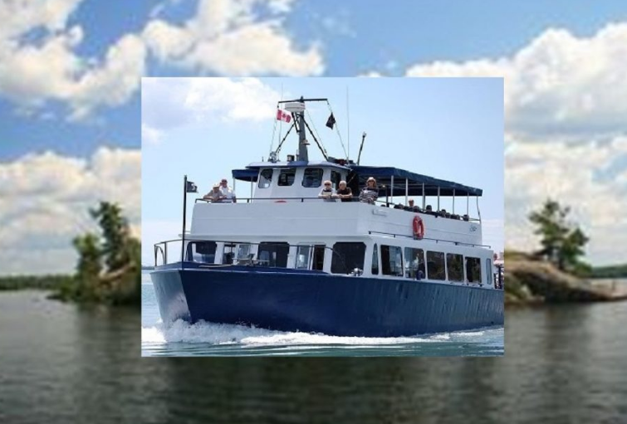
TEL. 226-787-7400
585 MOUNT JULIAN RD
NORTH KAWARTHA, ONTARIO
Spirit of the Kawarthas is the Largest Cruise Boat in the Kawarthas.
Daily sightseeing, lunch and dining cruises. Relax and enjoy a sumptuous meal or light snack and drink as you navigate the narrow channels among Stoney Lake’s 1128 islands. You will enjoy vistas of palatial waterfront homes, the famous glass house, the Ronnie Hawkins estate and much more. The Captain provides a live commentary with fascinating history of the area and the Trent Severn Waterway.
The ship is available for weddings, birthdays, anniversaries, corporate outings, fundraisers – or any special occasion!! Let the cruise professionals plan an event that will exceed your expectations.
The Ganaraska Trail is a recreational trail with a total length of 500 km. Since 1967 it has been developed and maintained solely by volunteers and private landowners. The trail stretches across every type of landscape possible. Its route crosses parts of the Somerville Tract and the Victoria Rail Trail.
The Kawartha section starts on the Victoria Rail Trail where it intersects with Crosswinds Road, south of Reaboro. It follows the rail trail to Lindsay, along the Scugog River for some distance, and then takes the Victoria County Recreation Corridor, which it follows to 2 km past Burnt River. At this point, the trail increasingly sees evidence of Canadian Shield country. The section ends in Moore Falls after 77 km or varied terrain. The first 50 km are flat, and the next 20 km are rugged. The last 5 km are on country paths from Buller Road to Moore Falls. This section is suitable for novices.
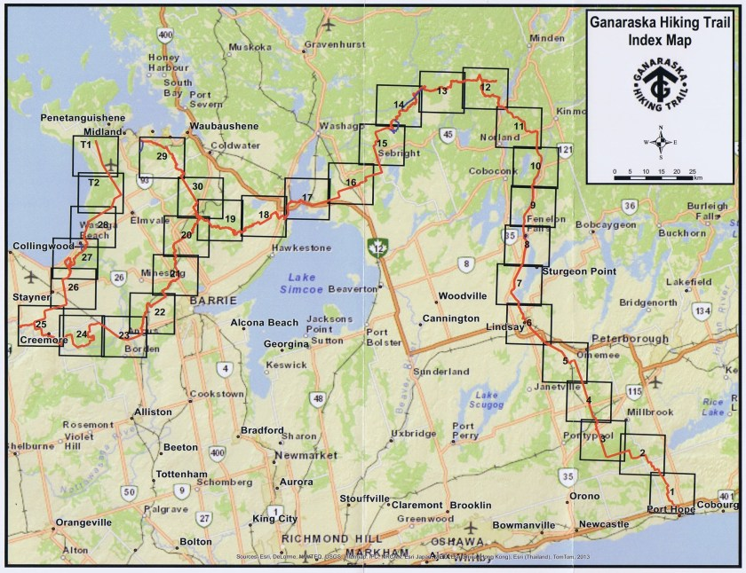

The Gut Conservation Area (Part of the Crow Valley Watershed)
http://www.crowevalley.com
South of Glen Alda and about 11 km east of Apsley is a unique, 400 acre, conservation area known as The Gut. A dramatic turn in the Crowe River forces the water over a falls, becoming a rugged gorge where the river has carved its way through thirty meters of Precambrian rock. The fissure that forms the gorge is over 30 meters high and varies from 5 to 10 meters in width. This Conservation Area features walking trails, a parking lot, a look-out area, and a stairway down to the gorge. The gorge presents a breathtaking glimpse of this unique terrain.
From Havelock, at Hwy 30 and 7, turn right on to County Rd # 46, Travel 42 km/ 26 miles to within 50 meters of Hwy 504 intersection, turn right onto Lasswade Rd and travel 6 km/ 4mi, look for the Gut Conservation Area sign and turn right on road for 1 km/.6 mi to the parking lot.

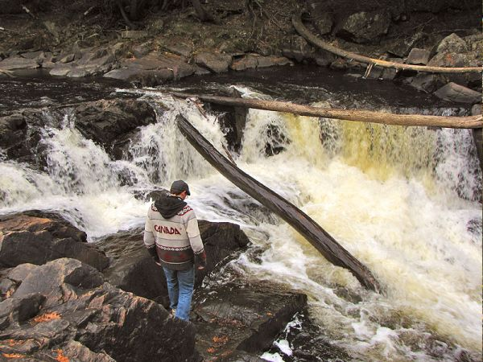

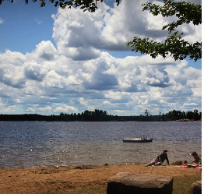
QUARRY BAY BEACH
A small public beach area along Northey’s Bay Road.

