BOBCAYGEON
Incorporated in 1876, this community is located on the Trent-Severn Waterway in the City of Kawartha Lakes. A popular tourist destination, it was made famous by the Canadian rock band, the Tragically Hip.

Bobcaygeon Beach Park & Boardwalk: 45 Park Street (has washrooms) A beautiful beach!
Forbert Memorial Pool & Park is located at 16 River Park Rd and is a more natural water access. There’s covered pavilion for picnics and a playground for the kids.
Lock 32 Park- Trent Severn
15 Bolton Street
In the heart of the village, with green space on either side of the swing bridge, you can relax on a bench and watch all kinds of boats on Trent Severn Waterway. Free outdoor music concerts on Thursday evenings in the summer- bring your own lawn chair.
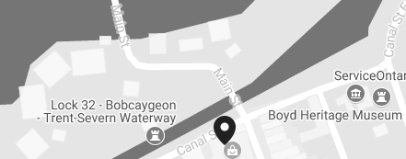
Tommy Anderson Park has a splash pad, sheltered picnic area, washrooms, playground, basketball, tennis courts, baseball fields, horseshoe pits, outdoor skating rink, skateboard park, soccer and football field.
Bobcaygeon Wilderness Park - 8 acres of mature forest with trails for hiking, cycling, cross country skiing and nature interpretation.
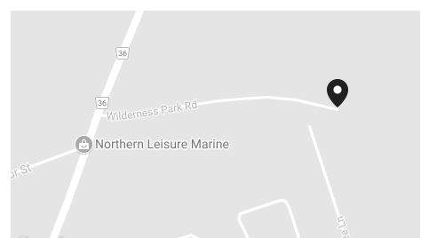

Big (Boyd/Chiminis) Island is located in Pigeon Lake and it’s the largest undeveloped island in the Kawarthas. 11085 acres with 10 km of shoreline has 8 kms of marked hiking trails.

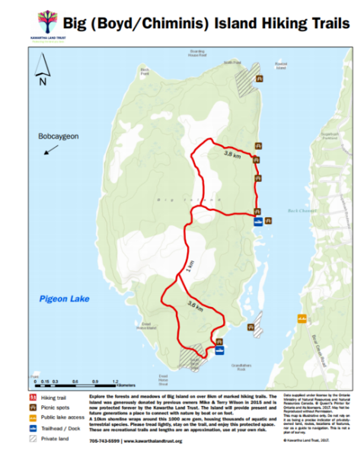
The Bobcaygeon Fair is held at the end of September.
http://www.visitbobcaygeon.com/

