BAPTISTE VILLAGE
The Village of Baptiste is little more than an old church, busy boat launch and a small grouping of houses & cottages these days. It was once a bustling train station, post office and logging stop, on the southern shore of beautiful Baptiste Lake.

Baptiste Lake is one of a chain of 3 lakes with Benoir and Elephant Lakes. It offers some 36 miles of boating with a maximum depth of about 32 meters.

Well known for superior fishing, Baptiste Lake has been home to a number of well-established lodges over the years. It is about 15 minutes from the town of Bancroft, and an hour south of Algonquin Park.

The lake has had a few different names including Kaijick Manitou, Loon Lake, Long Lake, and then finally was named Baptiste Lake after Chief Jean Baptiste, whose family is believed to be among the first original settlers.

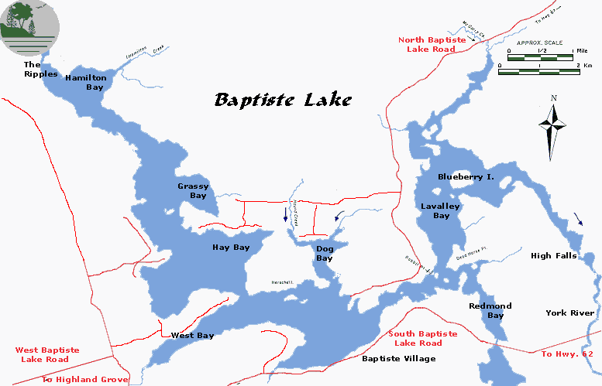
The Baptiste Lake Association baptistelake.org
For more history on the village, visit:
http://baptistelake.org/WS/Main/history.php
