IVANHOE
The charming hamlet of Ivanhoe is located 20 minutes north of Belleville on Highway 62.
There are a number of Amish Families in the area.
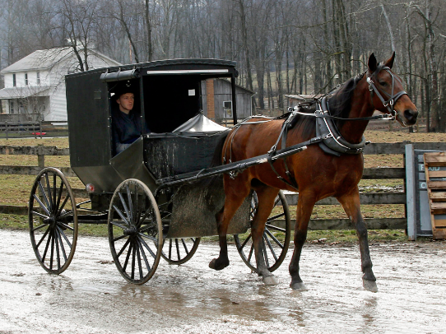
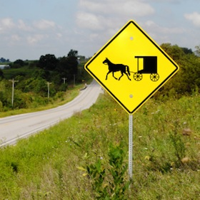
Ivanhoe Cheese Factory
11301 Highway 62
RR #5 Madoc
1-800-268-0508
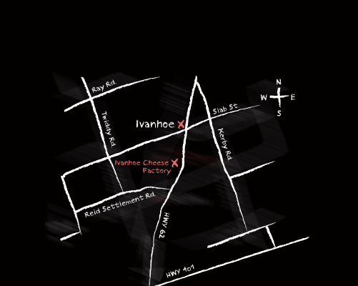
What began as a dairy cooperative in 1870, is now an award-winning artisan cheese factory that specializes in aged cheddars. Open year round (closed Christmas Day, Boxing Day & New Year’s Day).
Winter Hours January – March 31
Mon-Friday 9:00 to 5:30
Sat & Sun 10:00 to 5

Summer Hourshttps://www.google.ca/url?sa=i&source=images&cd=&ved=2ahUKEwjTjtHuj83gAhUNSK0KHflRCtcQjRx6BAgBEAU&url=https%3A%2F%2Fwww.123rf.com%2Fphoto_5984845_road-sign-amish-buggy-and-horse.html&psig=AOvVaw2gatHf_Q3TfVkwl83CAg1j&ust=1550848722695544
May long weekend to August long weekend
Saturday to Thursday 9-5 Friday 9-7
Remainder of the year 9-5:30

