IRONDALE
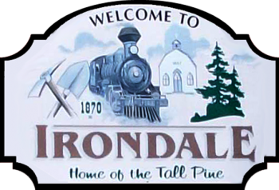
The hamlet of Irondale is located where the Monck Road (an important military/colonization road) crossed the Irondale River (a branch of the Burnt River). Most settlers farmed along the valley and many worked in the lumber industry. The post office was originally called Devil’s Creek (after the local lake now known as Salerno Lake). The old Monck Rd ran along the east side of the River but has since been relocated to the west side.
Iron ore was discovered in the area in 1870s and iron magnate Charles J Pusey made Devil’s Creek his mining centre, surveying a town site on Lot 17, Concession 5 in Snowdon Township. He extended the railway from Furnace Falls and named the newly formed village Irondale. By 1886, the IB&O Railway (so named after the 3 big towns of Irondale, Bancroft & Ottawa) reached the village and was extended to Bancroft soon after. The IB&O never got as far as Ottawa.
In 1891, Irondale had a busy railway station, 2 general stores, a blacksmith’s shop and Sam Hancock ran a hotel there. Iron ore was loaded and shipped from the station, via Howland Junction, to the Pusey Smelter in Cleveland, Ohio. Mining operations didn’t last long as the deposits were not as rich as anticipated and although the local lumber industry benefitted from the railway, until the best supplies were depleted. For a time, ice blocks were cut from Devil’s Lake and shipped in box cars to Toronto, until advances in modern appliances made that unnecessary.
