EGANVILLE
Eganville is located in a deep limestone valley carved at the Fifth Chute of the Bonnechere River in Renfrew County. It is known as the Ordovician Fossil Capital of Canada. Fossils in the area are over 500 million years ago. The nearby village of Douglas is a lively Irish community with an old-fashioned general store, crafts shops and galleries… but it’s especially exciting to be in Douglas for St. Patrick’s Day.
Eganville is also home to a Geo-Heritage Walking Trail located along the Bonnechere River which features a fossil pit, a visit to an old quarry, a trench, wild plants, and scenic lookouts.
Bonnechere Caves
1247 Fourth Chute Rd, Eganville
(Between Douglas & Eganville)
1-613-628-2283
cavemanchris@bennecherecaves.com
A natural underground wonder, the Bonnechere Caves has been welcoming people for 55 years plus. Guided tours every twenty to thirty minutes that last an hour. Adults $19, Seniors 65+ $17, Youth 13-17 $14, Chidren 4-12 $13, under 4 free
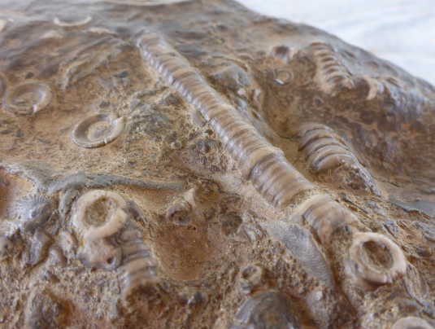
The Bonnechere Caves are today one of the must-see stops on any tour of the Ottawa Valley. Electric lights and dry, elevated boardwalks make access to the caves really easy and clean for the casual spelunker. The passages do not feel confining or spooky in any way but there is definitely an “other-worldliness” about the place. Dripping stalactites and moist walls set the imagination reeling in a fantasy, Harry Potter sort of way. The caves were formed five hundred million years ago on the when the area was actually a tropical sea and the passages are full of prehistoric fossils.
http://www.bonnecherecaves.com/

