KENNAWAY
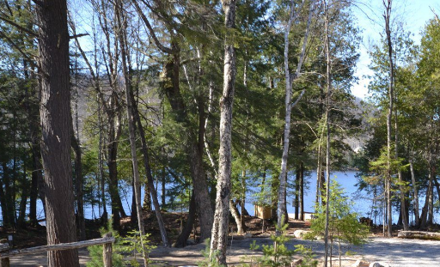
North on County Rd 10 (Elephant Lake Rd) to Fishtail Lake Rd
Kennaway started out as a farming community, just to the north of Harcourt. Settlement began in the 1860s, with a school house, grist mill, livery stable, post office and hotel. The stagecoach ran through Kennaway, enroute between Haliburton and Maynooth in the late 1880s. The road was rebuilt and improved by the G.W. Martin Lumber Company. While the old schoolhouse still stands (being used as a hunting camp) and you can still see the remnants of some old structures in the overgrowth, the settlement was largely abandoned in the 1930s.

