HAVELOCK
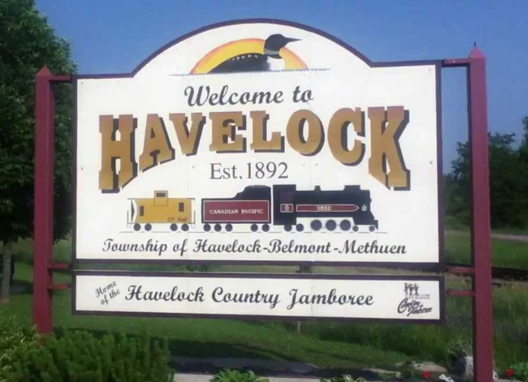
Incorporated as an independent village in 1892. Home to the Havelock Country Jamboree, Canada’s largest live country music and camping festival, it’s held over four days, in August every year. The twin stage festival has been going strong for nearly 30 years. http://havelockjamboree.com/
THINGS TO DO: http://calendar.hbmtwp.ca/
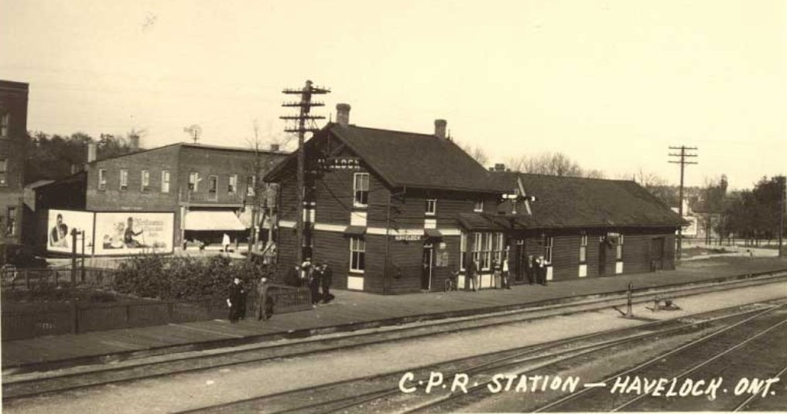
The Havelock-Belmont-Methuen Historical Society can be reached at havbelmet@hbmtwp.ca 705-778-2308

Mathison Property
The Mathison Property is a 250 acre natural area of scenic forests and wetlands located north of the Village of Havelock. It has 1.6 kilometers of multiuse trails for walking, biking and ATV/Snowmobiling and 1.1 kilometers of walking only trails. This property was graciously donated to the Township by John Mathison in 2001 for conservation, education and recreation purposes. Lookout, Picnic Area and Trails throughout!
